This is how these highly unethical, arrogant and publicly deceptive Society ceo Maher and his deceptive unethical colleagues really are showing contempt to their bishop because my wife is a friend of Cairns Bishop James Foley.

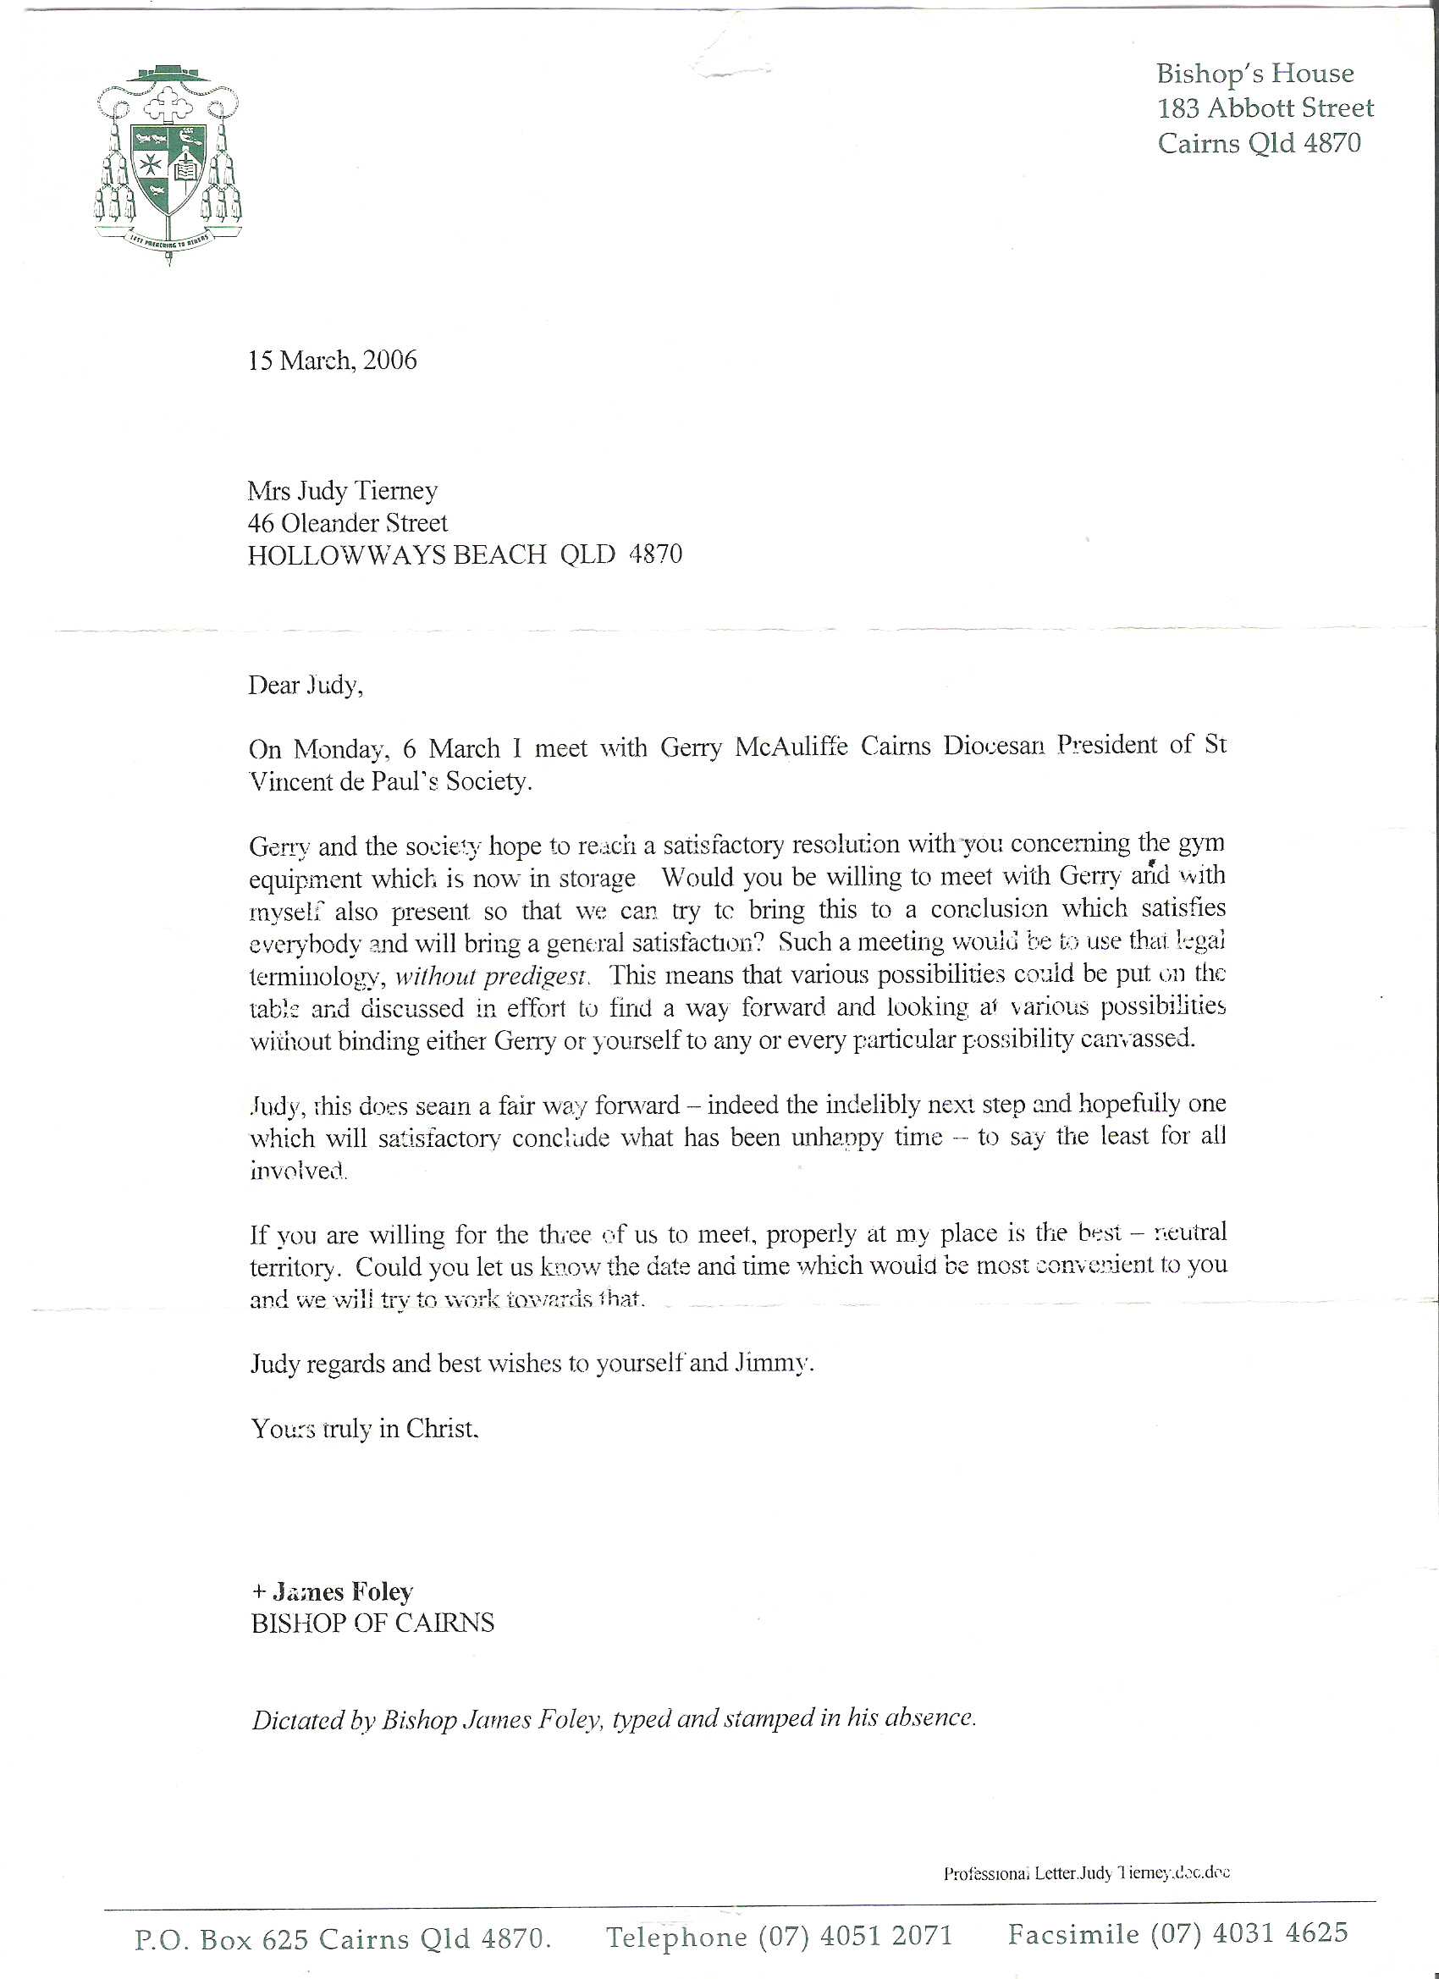

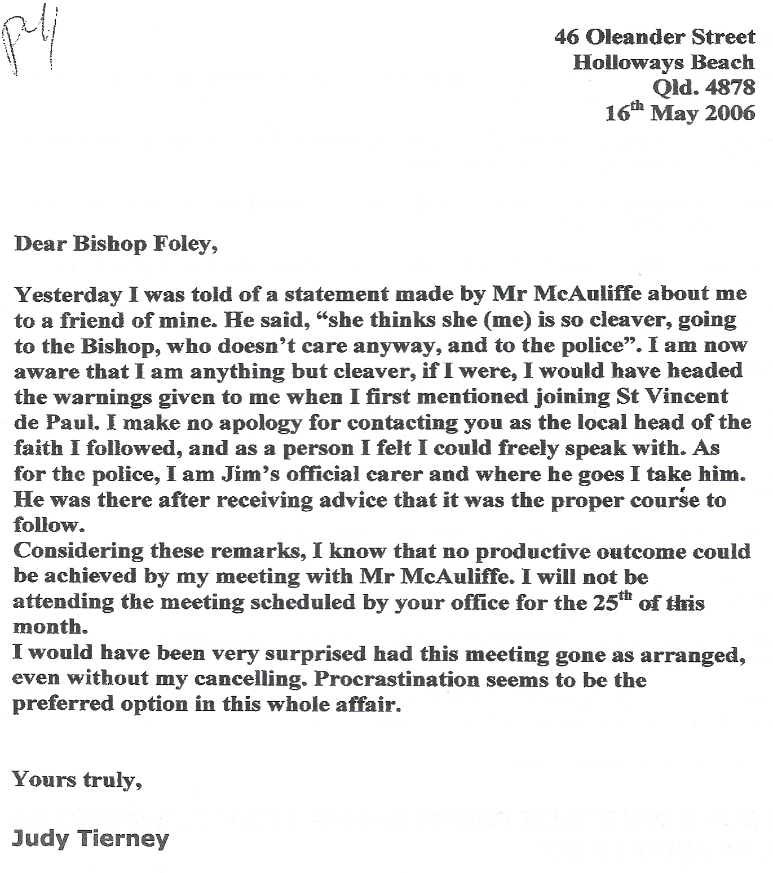
Judith Tierney response to Bishop James Foley this individual was one responsible to giving my wife a nervous breakdown.

Surely this shows how these thieves really act?

