THYNNE & MACARTNEY
MEMBER OF THE KENNEDY STRANG LEGAL GROUP
Level 27 12 Creek Street Brisbane Queensland 4000 Australia
Tel 61 73231 8888
Fax 61 73229 0855
www.thymac.com.au

Dear Mr.

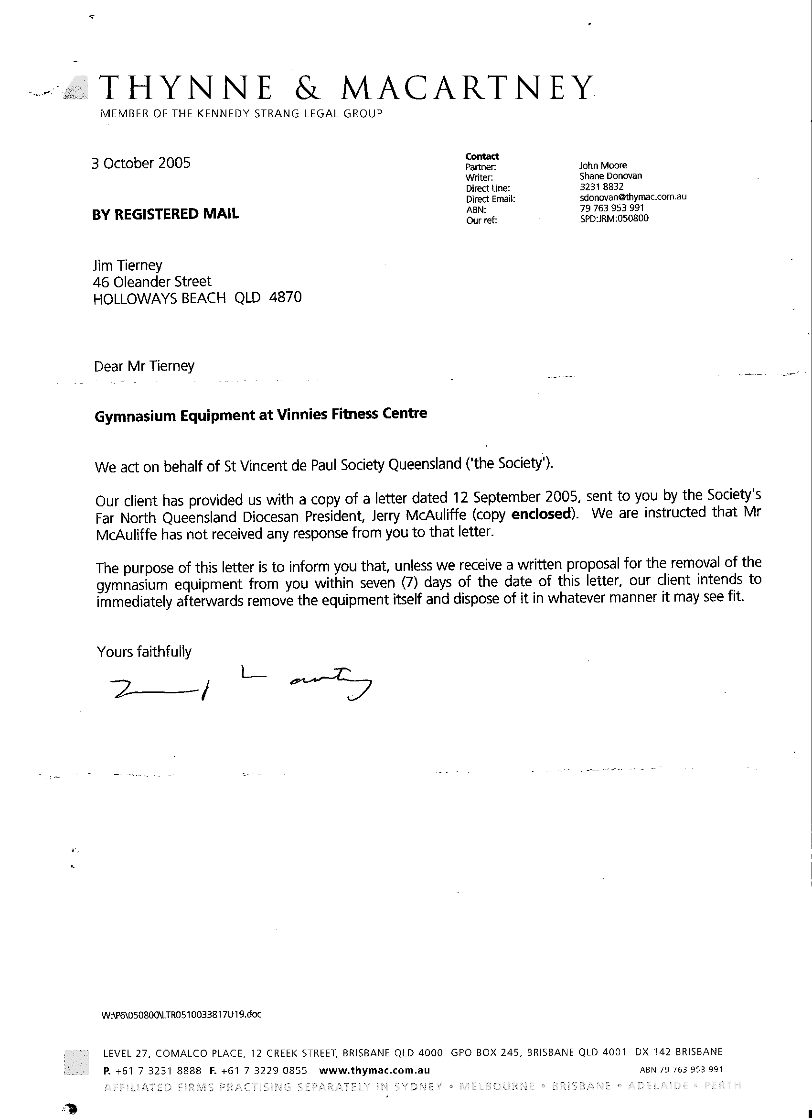

I would like to know by whom and when I was requested to show my PROFESSIONAL BOXING LICENSE.

From the time the fitness centre opened which was well before maher was employed by the society, not at any time have I been asked to produce my PROFESSIONAL BOXING LICENSE.

Are you aware that a PROFESSIONAL BOXING LICENSE IS A PRIVILEGE to have not a right?
If asked, would anyone think a HOLDER OF A PROFESSIONAL BOXING LICENSE would want to hide it?

And for your information it was I at a meeting with some of your clients that made them aware of the insurance needed.

TO MORE IMPORTANT THINGS I want the name of the person that maher alleges told him I JAMES VICTOR TIERNEY king hit a child. The same statement that the QLD State President (‘the society’) McKeown said maher had told him! THEN MCKEOWN REPEATED THE SAME STATEMENT TO MY WIFE. Any one with an ounce of sense would know one of them is wrong.

How dare you people say I donated a number of items of GYMNASIUM EQUIPMENT are you publicly saying you are now qualified to make statements of what constitutes a fitness centre?

How dare you!!!

If you are trying to INTIMIDATE me REGARDING the alleged INCIDENT THAT you state ****OCCURRED ON JUNE 8TH 2005.

AS CLINT EASTWOOD SAID,
“GO AHEAD MAKE MY DAY”

NOTHING WILL PLEASE ME MORE THAN TO BE GIVEN A PUBLIC PLATFORM

TO REPEAT WHAT I SAID IN FRONT OF MANY WITNESSES.

NOT THAT IT WILL MAKE ANY DIFFERENCE, AS SOON IT WILL ALL BE IN THE PUBLIC DOMAIN.

JAMES VICTOR TIERNEY

No response from these unprincipled solicitors.

This is more of this continuing attempt by Peter Maher to create more anxiety and anguish to both my wife who is my carer and me, giving instructions that are lies to society solicitors THYNNE & MACARTNEY. I have had it now!!

