EMPLOYEES AND OFFICE TITLES
The Society being a voluntary organisation must always be controlled and seen to be controlled by voluntary people.

With this in mind titles like executive director, executive secretary, etc., may at times give a wrong impression to organisations not conversant with our methods of operation. Accordingly administrative titles like general secretary or liaison officer are preferred.
National Council Decision, June 198O.

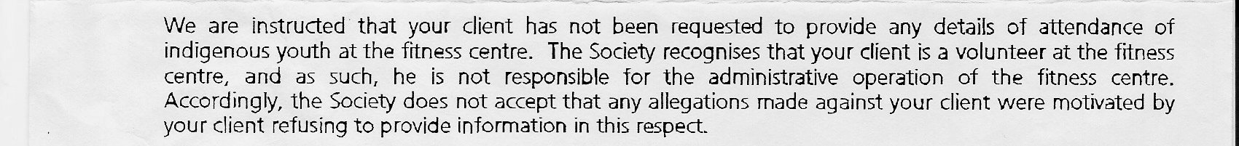
The Society recognises that your client is a VOLUNTEER at the Fitness Centre, and as such, he is not responsible for the administrative operation of the fitness centre.

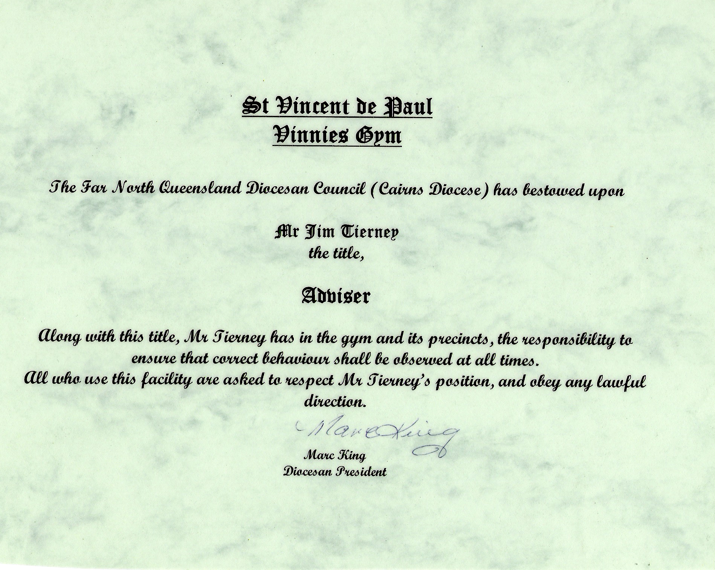

NO ONE IN THIS SOCIETY HAD BEEN INSIDE A GYM NEVER MIND RUN ONE!!!!
ARTICLE 32 - SPECIAL WORKS
Special works arise out of conference activity and are an example of mutual help and solidarity in that conference co-operate in the carrying out of good works.
A special work is desirable where a conference, or a group of conferences, finds a need that cannot be satisfied within the normal scope of conference activity and there is an opportunity and capacity for person- to person contact. It must be financed after budgeting for the normal activities of the conference.

THE LAW OFFICE

P.O. Box 1927, CAIRNS 4870
1ST FLOOR, 91-93 GRAFTON STREET, CAIRNS,
QUEENSLAND, AUSTRALIA
TEL: 0740314555 FAX: 0740314384
E:-M1AIL: lagois@lamaro.com.au
A.B.N. 94 540 511 271

OUR REF. JEM: KJN: 71721
YOUR REF.
5 September 2005

Mr & Mrs Tierney
46 Oleander Street
HOLLOWAYS BEACH QLD 4878

Dear Sir/Madam,

re: DEFAMATION - VINNY'S GYM CAIRNS

We refer to the above matter and now enclose copy of letter from Thynne & McCartney for your attention.

Upon receipt of this correspondence, would you please contact our office to make an appointment with Mr Magoffin to discuss this letter.

Yours faithfully

THE LAW OFFICE

JOHN MAGOFFIN

PARTNERS - ANTHONY LAGOIS * JOHN MAGOFFIN

