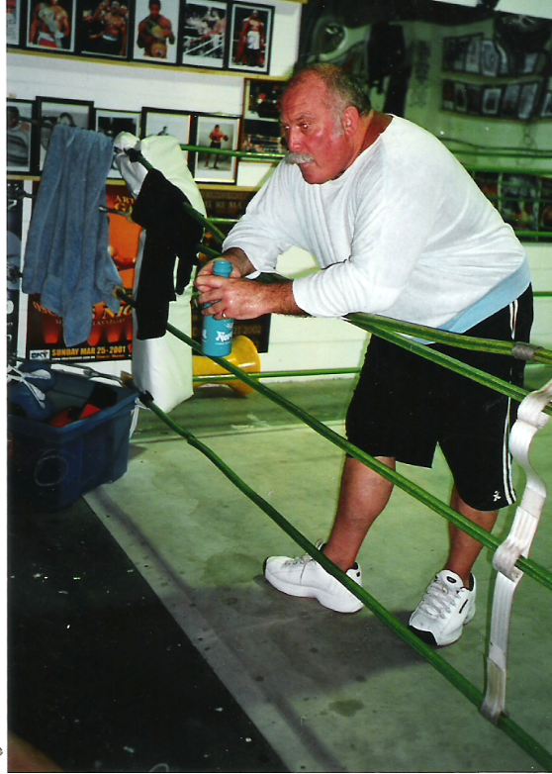

I conditionally donated close to a $ million dollars worth of equipment that went to make up the facility called Vinnies Gym in Cairns. I donated all this equipment specifically to the disadvantaged kids in Cairns. At the time of my donation Tim O’Connor was the Qld St Vincent de Paul State president. Tim, Judith my wife and me held a meeting at my home in Cairns. All conditions with my donation were accepted by Tim. I expressed to Tim O’Connor that I did not want anyone from the Society involved that would try to change my project, and make it a profitable enterprise.
As I donated it for the kids in Cairns that cannot afford to pay the usual gym fees.
More importantly because most of these youngsters I helped would not be welcomed in conventional gyms. The reader has to realised some of these kids lived on the streets or used drugs. Many had physical and mental health issues and with 40 + years experience in industries that use the many forms of weights fashion, perceived image is foremost in most of these establishments.
My perception of Tim O’Connor is he is a good man this was confirmed when he stated “Jimmy if we save only one kid from the streets it is a profit.”
The Society diocesan president Marc King made small wood boxes and Vinnies gym instructor Tony Walsh a heavyweight world Karate champion fixed these wood - now donation boxes on the walls of Vinnies Gym.
Dignity is all with young people so I suggested we put these donation boxes up and we could say a gold coin fee to use the gym if possible. Let this be made perfectly clear this donation was for dignity purposes only it was never intended to raise money. So initially Vinnies Gym was free to use for the truly disadvantaged. Desley Boyle MP presented me with an Australia day Certificate of Achievement for Services to Health & Fitness and the Youth of Cairns.
I established and presented my personal researched Anti – Rape programme in Vinnies Gym for young and elderly females. This would still be going as the response I received overwhelmed even me.
At this time the Society employed a youth coordinator named Francine Kubanek she asked me to attend an open day at St Monica’s college.
At first I declined, as the responsibility of instructing young girls with my hands on Anti – Rape programme is no easy task.
Francine absolutely loved life and just glowed with passion when helping disadvantaged kids and she was successful in me attending the St Monica’s college open day.
Teachers, students everyone assembled in their college hall to meet me and find out what was I about.
I was surprised with both my reception and the teacher’s ingenuousness as I talked about topics most avoid.
97 students signed on to my first hopefully one of many Anti – Rape classes encouraged by their teachers wanting to participate too.
Francine set about with passion organising the documentation and advertising required.

Everything was going well until I met with Francine in her Society office to finalise the first Anti – Rape class. Then the reality of workplace bullying became obvious towards Francine Kubanek from Cairns administrator Maree Fell. I must admit I had never experienced this before and I was about to teach hundreds of Ladies my hands on Anti – Rape programme.
Maree Fell’s verbal abuse to Francine shocked me as I have never experienced this before.
I looked at Maree who by then was making personal hateful repulsive remarks about the Anti – Rape programme and Francine’s involvement in them.

This bullying of Francine by Maree Fell continued till Francine had to resign. Just before Francine resigned she was advised by Judith Tierney to write down every incident she felt she was harassed and bullied by Maree fell reluctantly she did.

One day while I was there McAuliffe entered the Gym mumbling then just left.
He rarely came to Vinnies Gym he told me himself he was always using large amounts of prescribed morphine and spent frequent weeks at a time horizontal in hospital. I asked him if he was ever concerned about the addictive properties of morphine he just replied it’s not addictive.

Maree Fells bullying of Francine peaked so Francine requested to speak to Society ceo Maher in Brisbane.
She met with Maher but Francine told Judith and me he was only concerned about Francine getting grants for no less than $40,000.



