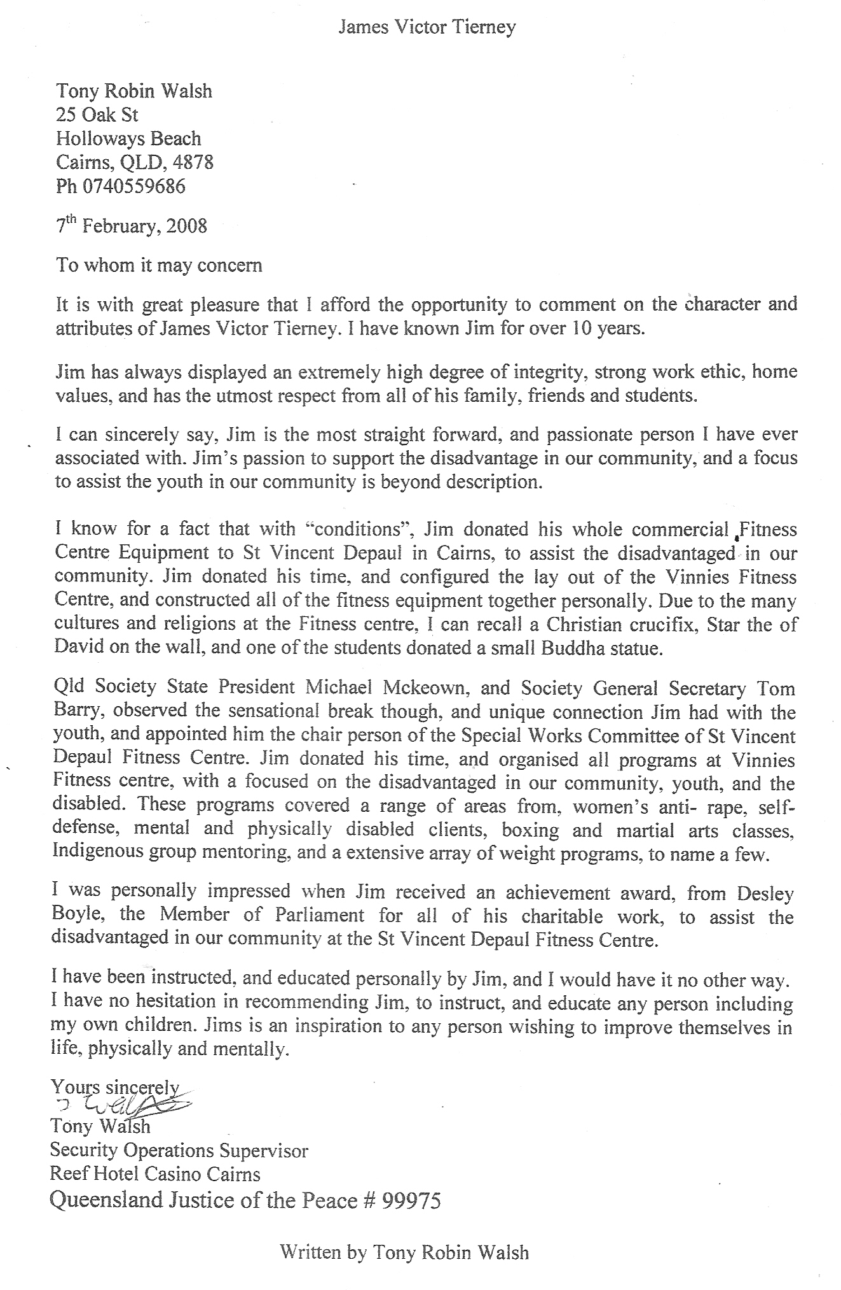
This X Vinnies Gym instructor resigned because of harassment and bullying to change number of ONLY indigenous people using Vinnies Gym to allow the Queensland society to get grants from the government.

