●●●●●●●●●●●●●●●●●●●●●●●●●●●●●●●●●●●●●●●●●●●●●●●●●●●●●●●●●●●●

COPY
- Original Message --
From: Maree Fell
To: Judv Tiernev
Cc: Jerrv McAuliffe
Sent: Wednesday, April 06, 2005 4:01 PM
Subject: Antique sale

Judy, just to let you know, today at the Centre Co ordinators meeting it was decided to have the antique/old wares sale on Saturday 7 May here at Anderson St. After this sale all old wares will be collected at the depot, then cleaned and marked and the each Centre Co ordinator can take what they wish to THE EMAIL THAT OFFENED SVDP STATE VICE PRESIDENT JUDY TIERNEY sell in their Centre. The prices placed on these items should not be changed once they leave the depot. Can you please contact me regarding this sale. The Centre Co ordinators would like to thank you for all your time and effort spent on cleaning and collecting old wares. Thanks Maree
--------------------------------------------------
QLD SVDP Administrator Mrs. Maree Fell stops Judy Tierney doing the old wares sales because the money was going to help Francine and the kids camp. This woman went around all the charity shops telling the volunteers Judy Tierney DID NOT WANT TO DO THESE SALES ANY MORE. NOT TRUE IT WAS A MALIOUS LIE.

●●●●●●●●●●●●●●●●●●●●●●●●●●●●●●●●●●●●●●●●●●

Wednesday, April 13, 2005 11:08 AM
MY Email to CEO Maher telling him things he knew was going on. TIME FOR ME TO GO! COPY

----- Original Message -----
From: jjls@bigpond.com
To: Peter Maher
Sent: Wednesday, April 13, 2005 11:08 AM
Subject: unexceptible behaviour

Dear Peter,
I am appalled the way my wife JUDE has been treated by these paid professional people that are accountable to you. I have caught pneumonia because of the constant temperature changes I experience in the gym teaching and writing programs. I teach anti-rape classes for young and old that I could not do without Francine's profession help but more importantly her enthusiasm. She introduces me to people who would normally not have a bar of me, I have lived in Australia for over 30 years but I will always be an unwelcomed pommie bastard. I ask Francine how she copes because of her daily fear of wondering if it will it be today they will push her too far and resigning is her only option to get away from the consistent stress she is always under. I come from poverty like millions of people from Liverpool I have been around the world many times.
So when Jude first started with this society I was not happy at all! If you were whacked as a child as often as I was by these religious people you could (maybe) understand. Then I watched how she gained the trust of the invisible elderly volunteers. One time Jude had to tell the female lover of the societies female administrator to leave and stop standing
over these wonderful elderly ladies. The majority not even knowing what a lesbian was. For this action she had to go and defend herself being accused of dismissing the female administrators lover because she was a lesbian. She attended that procedure on her own with no support from any member from this society.
I opened my computer last week there was a deliberate insulting e-letter addressed to Jude telling her after four years she was NOT doing the old wares sales any more. She was not informed by phone but by e-mail the president was in attendance at this store meeting also. Yet she was told by e-letter by this wonderful Christian lady on the pay roll. As I am writing this I really cannot believe people are capable of such rude behaviour. The day Jude received this information I was struggling to breathe because of pneumonia.
I told Jude she had better read the information sent to her, after reading the insulting words she started to sob-then much to my horror sobbed- and sobbed then locked herself in our bedroom. I tried getting in touch with the State President I remind you again I was suffering from pneumonia while this nonsense was going on.
Fortunately I was able to ring John Campbell and asked him to inform the State President I also rang this person here who asked me what it had to do with John and the State President. RE:the old wares.
You people may not know this but Jude was a director of a psychiatric hospital yet here she was sobbing uncontrollable and please remember I remind you again I had pneumonia.
Now she is being accused of attending the gym too much (she is first of all taxiing me back and forwards to the gym almost daily BUT I CAN CHANGE THAT EASY- then helping seriously mentally disturbed souls, that no one else gives two bits about yet she is going too frequently) can you please do something about this before I do?
I have watched her for four years- daily, spend hours and I mean literally hours cleaning what some people perceived as rubbish (my HOME littered with boxes and boxes of rubbish my money my expensive gadget cleaning things my bills) to establish in the publics eyes in her own small way that this society does care.
Peter the reason I have underlined the word some because for years others knew of the value of this rubbish and now very little is available because Jude has been collecting it. We know the amount she receives is minimal but her sales has alerted too many the value of this rubbish. The day Jude and I supported Francine was the start of all this. Jude should have resigned after her insulting e-letter with Jude being the only buffer between Francine and the wolves.

JAMES VICTOR TIERNEY.
COPY

●●●●●●●●●●●●●●●●●●●●●●●●●●●●●●●●●●●●●●●●●●

●●●●●●●●●●●●●●●●●●●●●●●●●●●●●●●●●●●●●●●●●●●●●●●●● COPY
I was struggling to breathe because of pneumonia confirmed by SVDP youth Coordinator Franine Kubanek. Francine left because of the persistent bullying she was under.

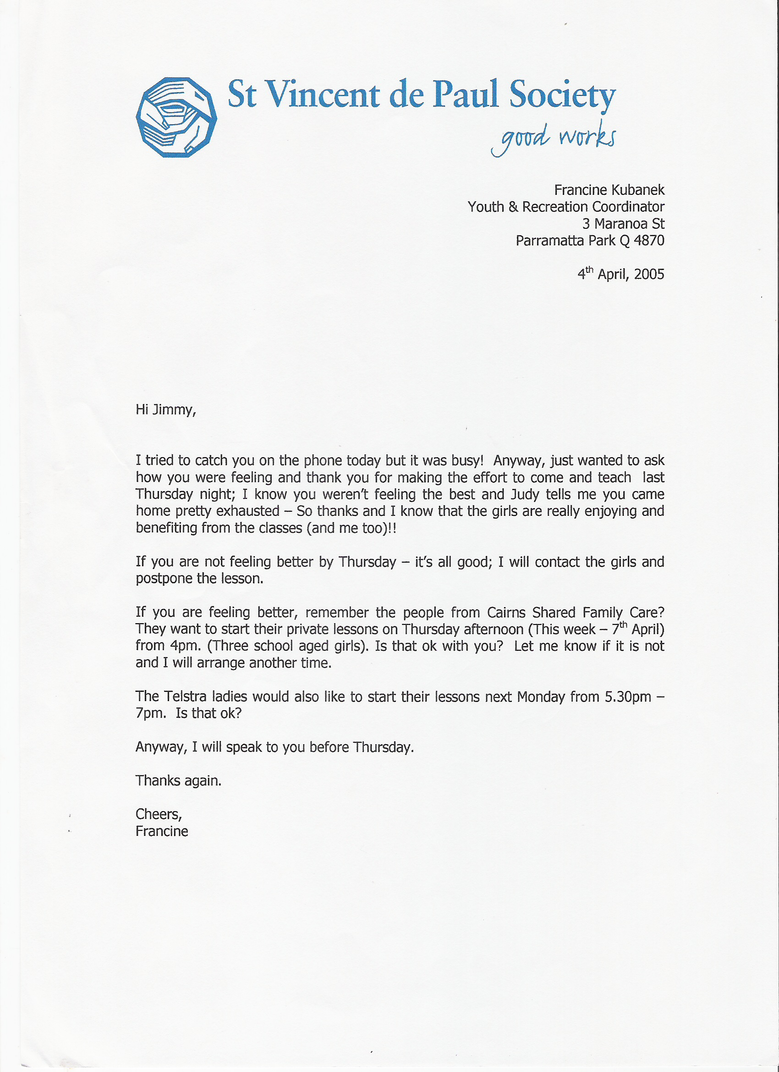
●●●●●●●●●●●●●●●●●●●●●●●●●●●●●●●●●●●●●●●●●●

●●●●●●●●●●●●●●●●●●●●●●●●●●●●●●●●●●●●●●●●●●●●●●●●●

JIM TIERNEY Email to CEO Maher. Thursday, 5 May 2005 11:14 AM
COPY
From: jjls@bigpond.com
Sent: Thursday, 5 May 2005 11:14 AM
To: Peter Maher
Subject: answer

As I have not heard from you I wonder if you received my e-mail dated 14/04/2005.
JVT.
No virus found in this incoming message.
Checked by AVG Anti-Virus.
Version: 7.0.308 / Virus Database: 266.11.5 - Release Date: 4/05/2005

●●●●●●●●●●●●●●●●●●●●●●●●●●●●●●●●●●●●●●●●●●

Maher replies after me leaving numerous messages for him.
Friday, May 06, 2005 11:46 AM

COPY
----- Original Message -----
From: Peter Maher
To: jjls@bigpond.com
Sent: Friday, May 06, 2005 11:46 AM
Subject: RE: answer

Yes Jimmy, I did receive your email and I understood that Michael had spoken to Judy about some of the concerns that you raised. So I did not reply.
The society values the wonderful contribution of all its volunteers including the work that both you and Judy do.
Sometimes misunderstandings happen which are not intentional. We need to make sure that we continue to reflect on why we do what we do. It is also important to try new things and to be open to change. I know sometimes it is hard to let go of things.
I am also conscious that people do things sometimes without thinking of how their actions may affect others, often it is not intentional. We need to be forgiving people, that is a real challenge at times, but one that we should persist with. We should also stop occasionally to reflect on all the people whose lives have been enriched because they have been impacted by the work that individuals like you and Judy have done through the society.
I am also conscious that Francine appreciated all the support that she receives from you. I have also spoken with her about strategies that she could use to assist her and Maree to work together more effectively and to let her know that I am available at any time should she wish to have a chat.
Peter
_________________________________________________________________________
Peter L Maher
Chief Executive Officer
St Vincent de Paul Society

State Council of Queensland
10 Merivale Street
South Brisbane QLD 4101
PO Box 3351
South Brisbane QLD 4101
Ph: 07 3010 1000 Ph: 07 3010 1001 (direct)Fax: 07 3010 1099 Mobile: 0400 200 309 St Vincent de Paul Society, celebrating 150 years of providing a hand up to those in need. Assistance includes: * Home Hospital and Prison Visitation * Family Support *St Vinnies Clothing Centres *Migrant and Refugee Support *Support for the Homeless and those at risk of Homelessness *Disaster Welfare *Emergency Accommodation *Child and Family Program *Youth and Young Adult Support and *Overseas Partnership Development COPY
●●●●●●●●●●●●●●●●●●●●●●●●●●●●●●●●●●●●●●●●●●

One day I went to the QLD SVDP gym and this stranger (HOGAN) asked me who I was, then said “You had a registered letter sent to you on 10 JUNE 2005 telling you to keep away from the gym from the CEO”. I asked him who he was; he said that QLD SVDP CEO had paid him to do an assessment on the gym.
I returned home and rang the CEO’s office, I asked him what was going on, as I have been supervising, and running my own courses, in the gym for four years. He told me he sent me a registered letter on 10 JUNE telling me to keep out of the gym.
I stated to him, if he had, sent a registered letter to me he would have the receipt, and that I would have had to sign for it. I demanded either he sent me a copy of this receipt or copy of the letter. I told him he was lying and in total disgust I handed the phone to Jude my wife.
Maher then stated to my wife that “I should have received his registered letter”, she stated, no letter, registered or not, has been sent to this house, and what is he on about. She demanded a copy of the letter or receipt immediately.

He went on to tell my wife that when he was in Cairns he visited other gyms asking people about me. Then stated to Jude my wife, the Catholic Board that she was part of, wanted me out of the Society.

Judy Tierney immediately rang the State President Michael McKeown in Brisbane. State President Michael McKeown stated I [JAMES V. TIERNEY] had KING HIT a child, at a fight night because the decision did not go the way for my boxer.

She asked State President Michael McKeown, who had made this allegation about me; he said that CEO Maher had told him. So they wanted me to stay away from the gym, as it was not good for the image of S V D P.

●●●●●●●●●●●●●●●●●●●●●●●●●●●●●●●●●●●●●●●●●●

BELOW A COPY OF THE LETTER SENT TO ME FROM MAHER AFTER THE ABOVE

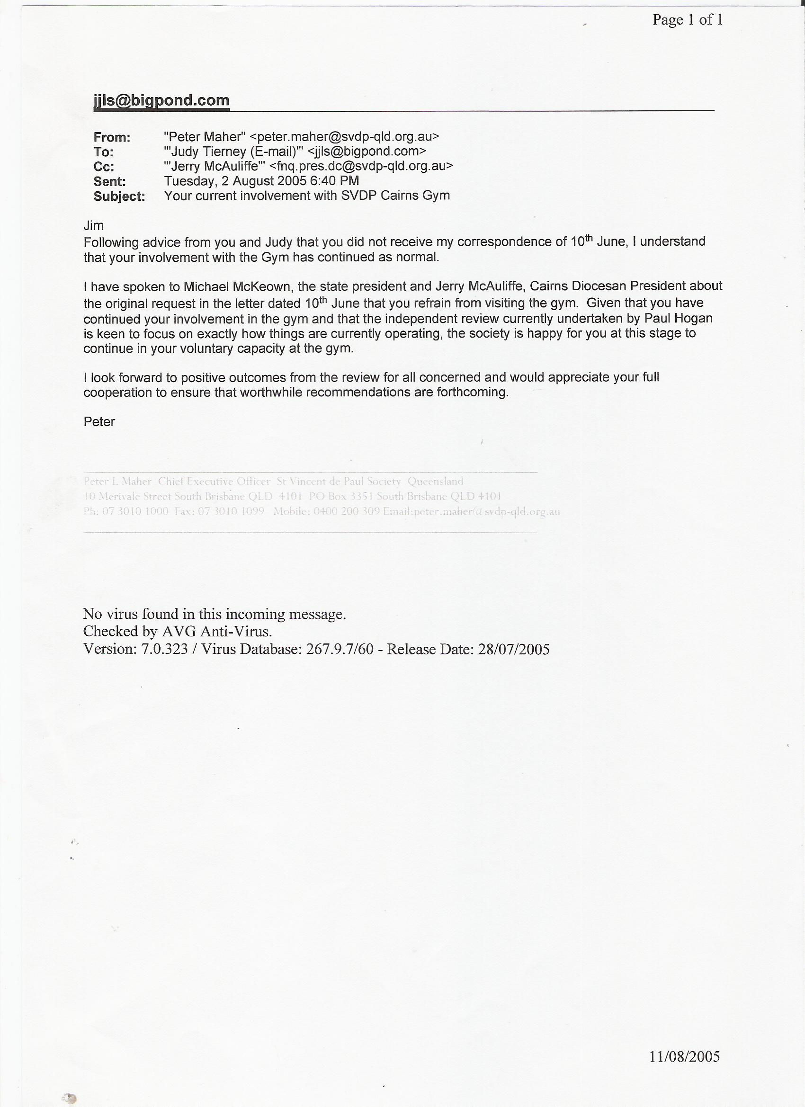
COPY

●●●●●●●●●●●●●●●●●●●●●●●●●●●●●●●●●●●●●●●●●●

●●●●●●●●●●●●●●●●●●●●●●●●●●●●●●●●●●●●●●●●●●●●●●●●●●●●●●●●●●●●

I went to a solicitor, and requested he write to Maher on my behalf asking Maher to divulge the following: 1. The name of the person who made this allegation about me. 2. A copy of the receipt or registered letter, he said he sent to me. 3. A copy of the complaint about me, as I understand if such a complaint is accepted, I have the right to know what it is in order to answer. BELOW A COPY FROM MY SOLICITORS, THE LAW OFFICE. AND COPY FROM SVDP SOLICITORS.

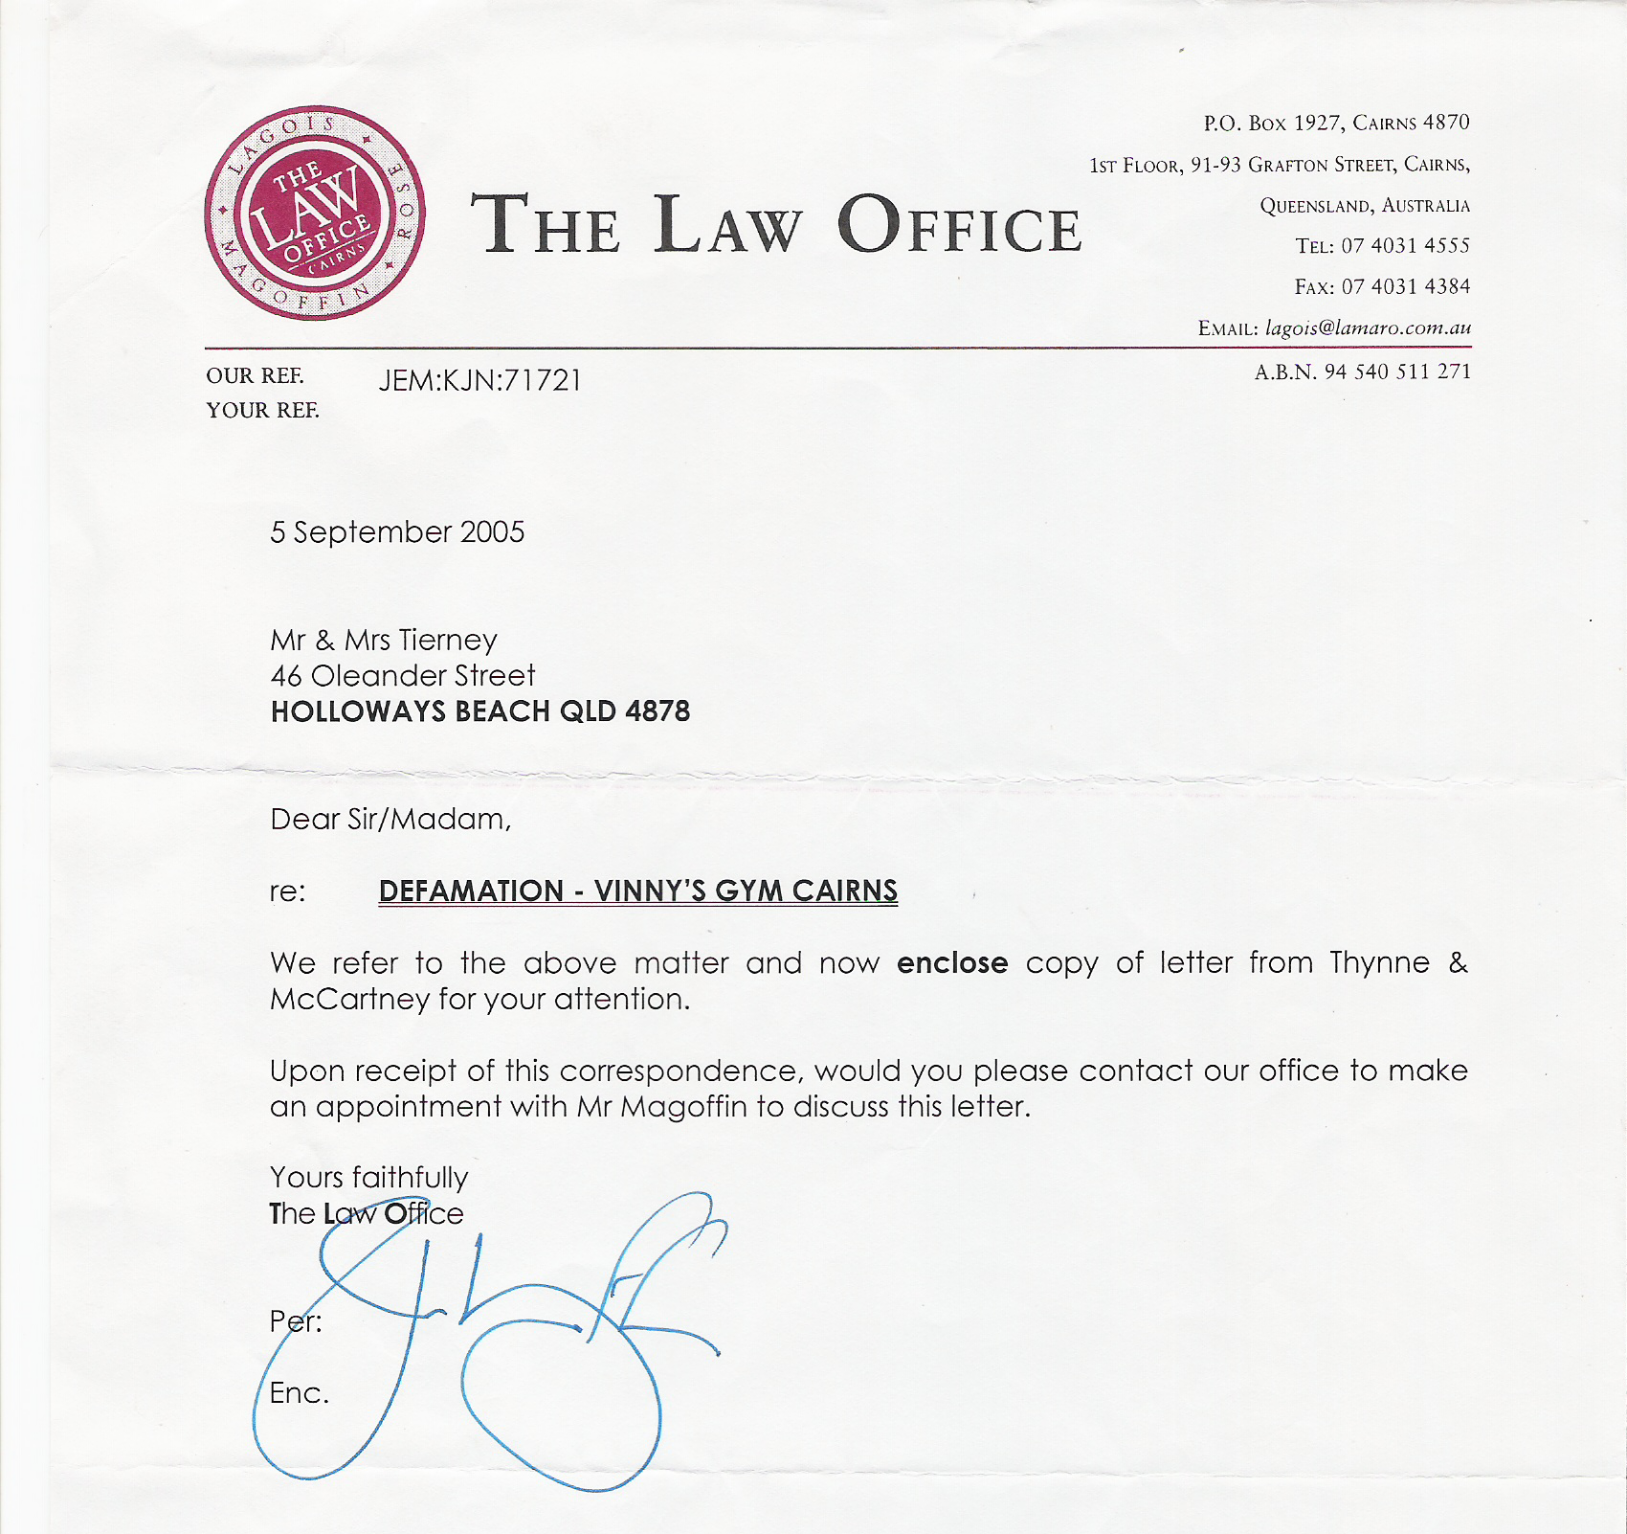
My wife Judy Tierney never said Maher told her, about the allegation of me KING HITTING a child. She stated it was State President Michael McKeown that informed her of the allegation. That Maher told him [Michael McKeown] I [Jim Tierney] KING HIT a child.
I knew Maher’s legal fees would be paid by SVDP. I decided to follow a different path.

COPY
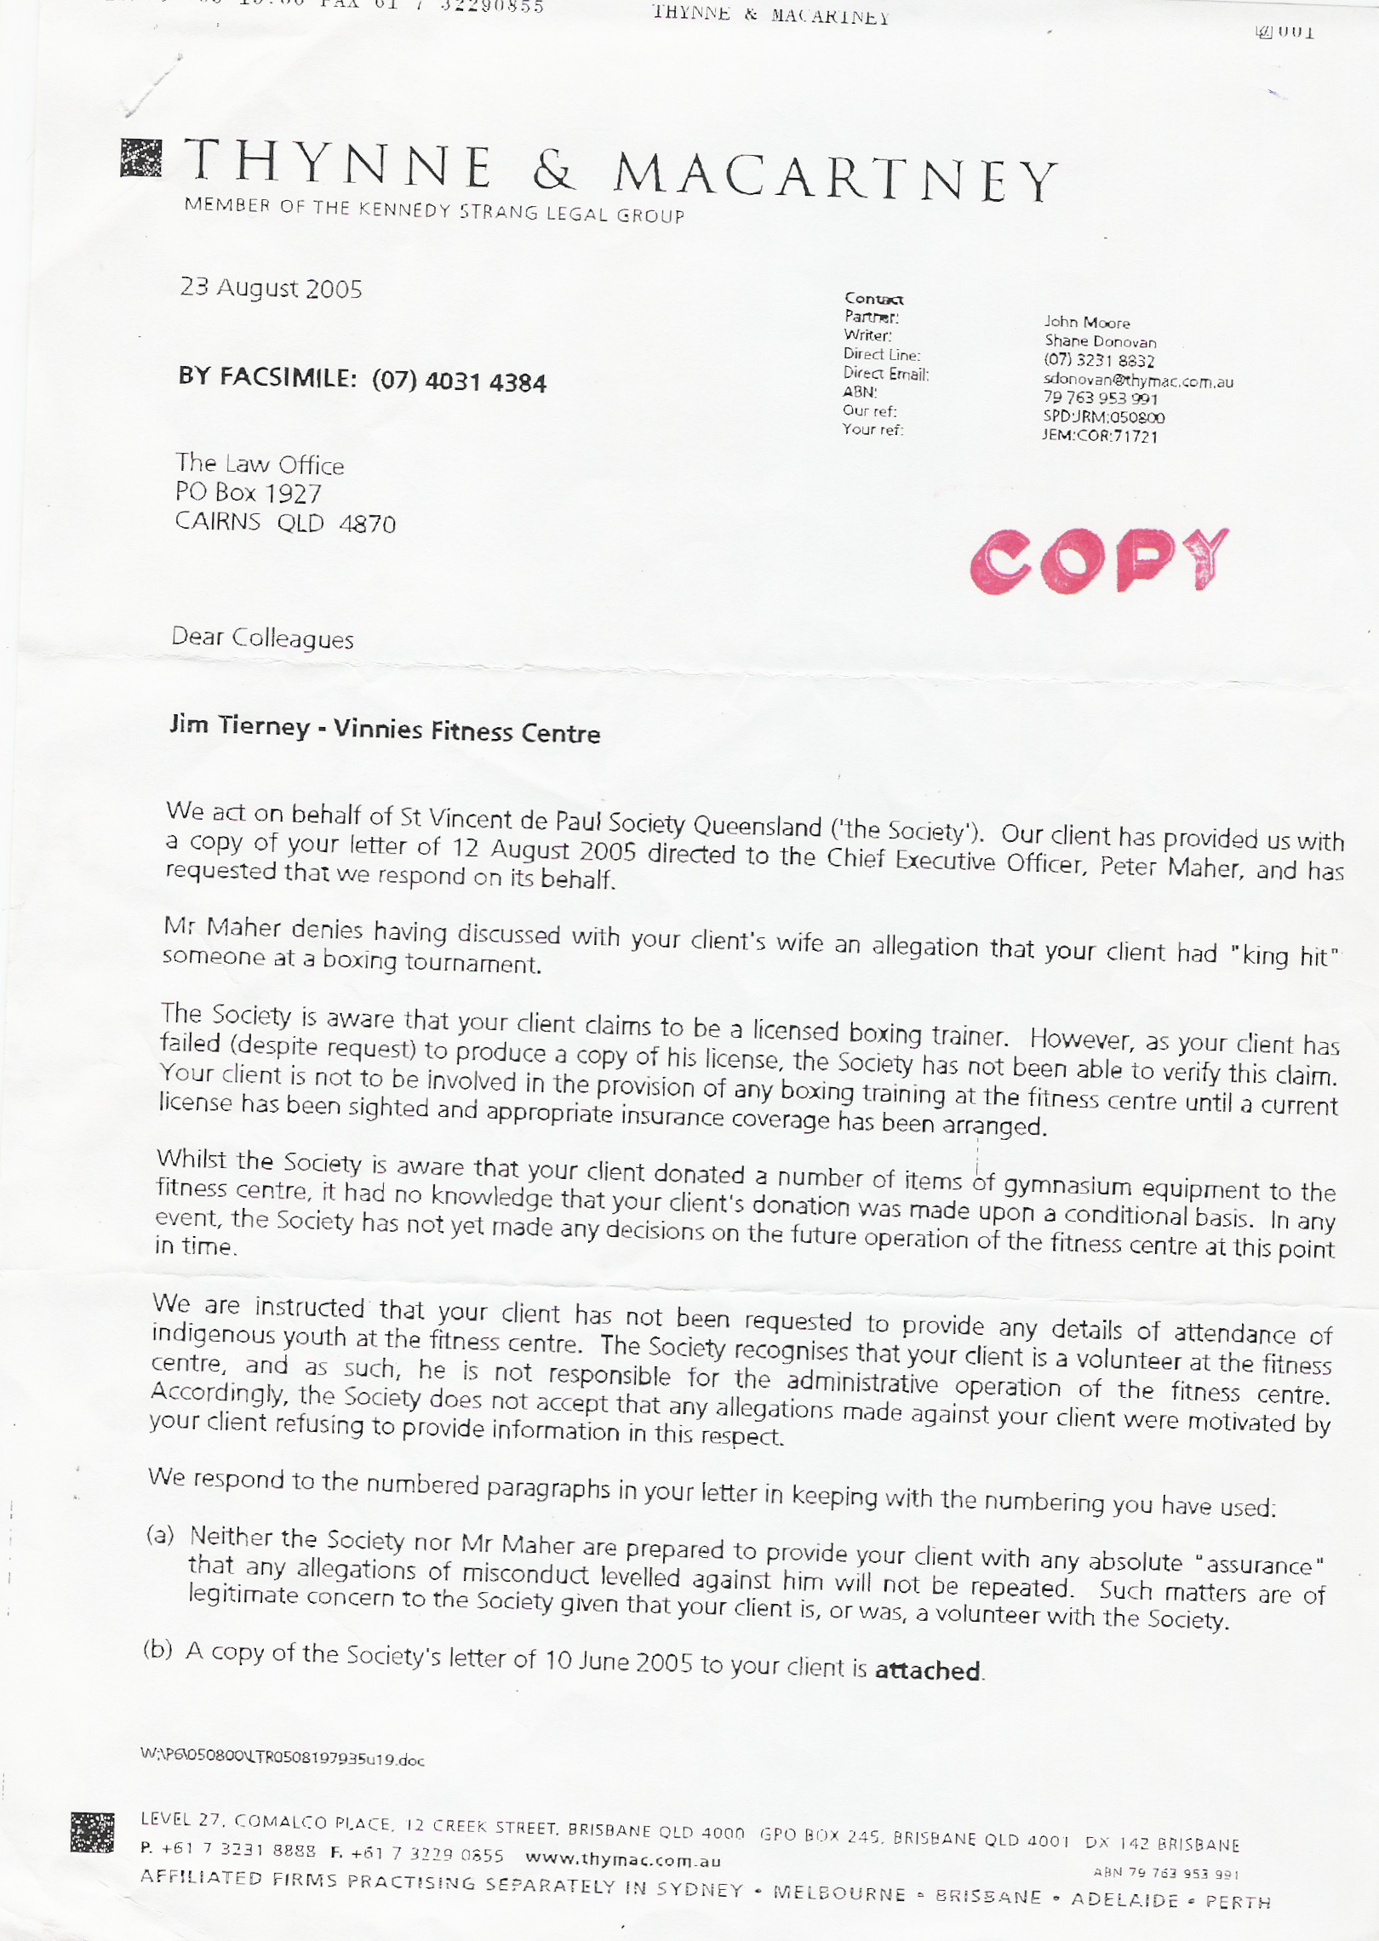

COPY

●●●●●●●●●●●●●●●●●●●●●●●●●●●●●●●●●●●●●●●●●●

●●●●●●●●●●●●●●●●●●●●●●●●●●●●●●●●●●●●●●●●●●●●●●●●●●●●●●●●●●●●
COPIED SECTION FROM SVDP SOLICITORS.
I JIM TIERNEY REPLY TO SVDP SOLICITORS THYNNE & MACARTNEY REGARDING NONSENSE! As your client has failed (despite request) to produce a copy of his license.

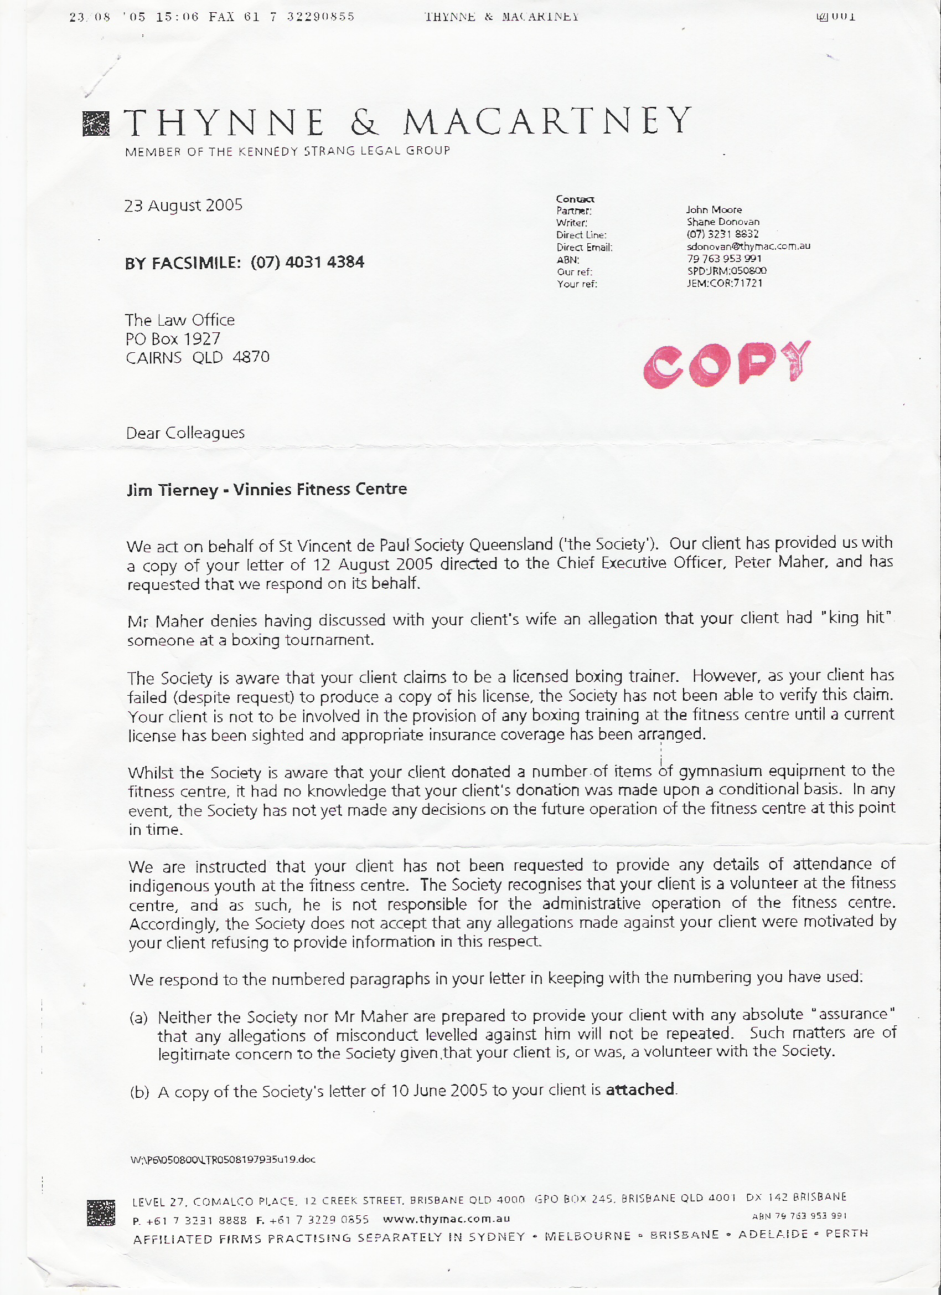

COPIED SECTION FROM SVDP SOLICITORS.

A NUMBER OF ITEMS OF GYMNASIUM EQUIPMENT

●●●●●●●●●●●●●●●●●●●●●●●●●●●●●●●●●●●●●●●●●●●●●●●●●●●●●●●●●●●●

●●●●●●●●●●●●●●●●●●●●●●●●●●●●●●●●●●●●●●●●●●●●●●●●●●●●●●●●●●●●●●●●●

COPY OF MY RESPONSE TO SVDP SOLICITORS REGARDING-1. A NUMBER OF ITEMS OF GYMNASIUM EQUIPMENT- AND 2. THEM LYING ABOUT REQUESTING TO SEE MY BOXING LICENSE. COPY

Dear Mr.

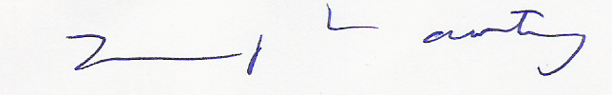
I would like to know by whom and when I was requested to show my PROFESSIONAL BOXING LICENSE. From the time the fitness centre opened which was well before Maher was employed by the society, not at any time have I been asked to produce my PROFESSIONAL BOXING LICENSE.
Are you aware that a PROFESSIONAL BOXING LICENSE IS A PRIVILEGE to have not a right?
If asked would anyone think a HOLDER OF A PROFESSIONAL BOXING LICENSE would want to hide it? And for your information it was I at a meeting with some of your clients that made them aware of the insurance needed.
TO MORE IMPORTANT THINGS I want the name of the person that Maher alleges told him I JAMES VICTOR TIERNEY king hit a child. The same statement that the QLD State President (‘the society’) McKeown said Maher had told him! THEN MCKEOWN REPEATED THE SAME STATEMENT TO MY WIFE.
Any one with an ounce of sense would know one of them is wrong. How dare you people say I donated a number of items of GYMNASIUM EQUIPMENT are you publicly saying you are now qualified to make statements of what constitutes a fitness centre? How dare you!!!

If you are trying to INTIMIDATE me REGARDING the alleged INCIDENT THAT you state OCCURRED ON JUNE 8TH 2005. AS CLINT EASTWOOD SAID, “GO AHEAD MAKE
MY DAY” NOTHING WILL PLEASE ME MORE THAN TO BE GIVEN A PUBLIC PLATFORM TO REPEAT WHAT I SAID IN FRONT OF MANY WITNESSES. NOT THAT IT WILL MAKE ANY DIFFERENCE, AS SOON IT WILL ALL BE IN THE PUBLIC DOMAIN.
JAMES VICTOR TIERNEY.

NO RESPONSE!

●●●●●●●●●●●●●●●●●●●●●●●●●●●●●●●●●●●●●●●●●●

●●●●●●●●●●●●●●●●●●●●●●●●●●●●●●●●●●●●●●●●●●●

12 Sep 2005 Maher and McAuliffe resolve their problem.

COPY

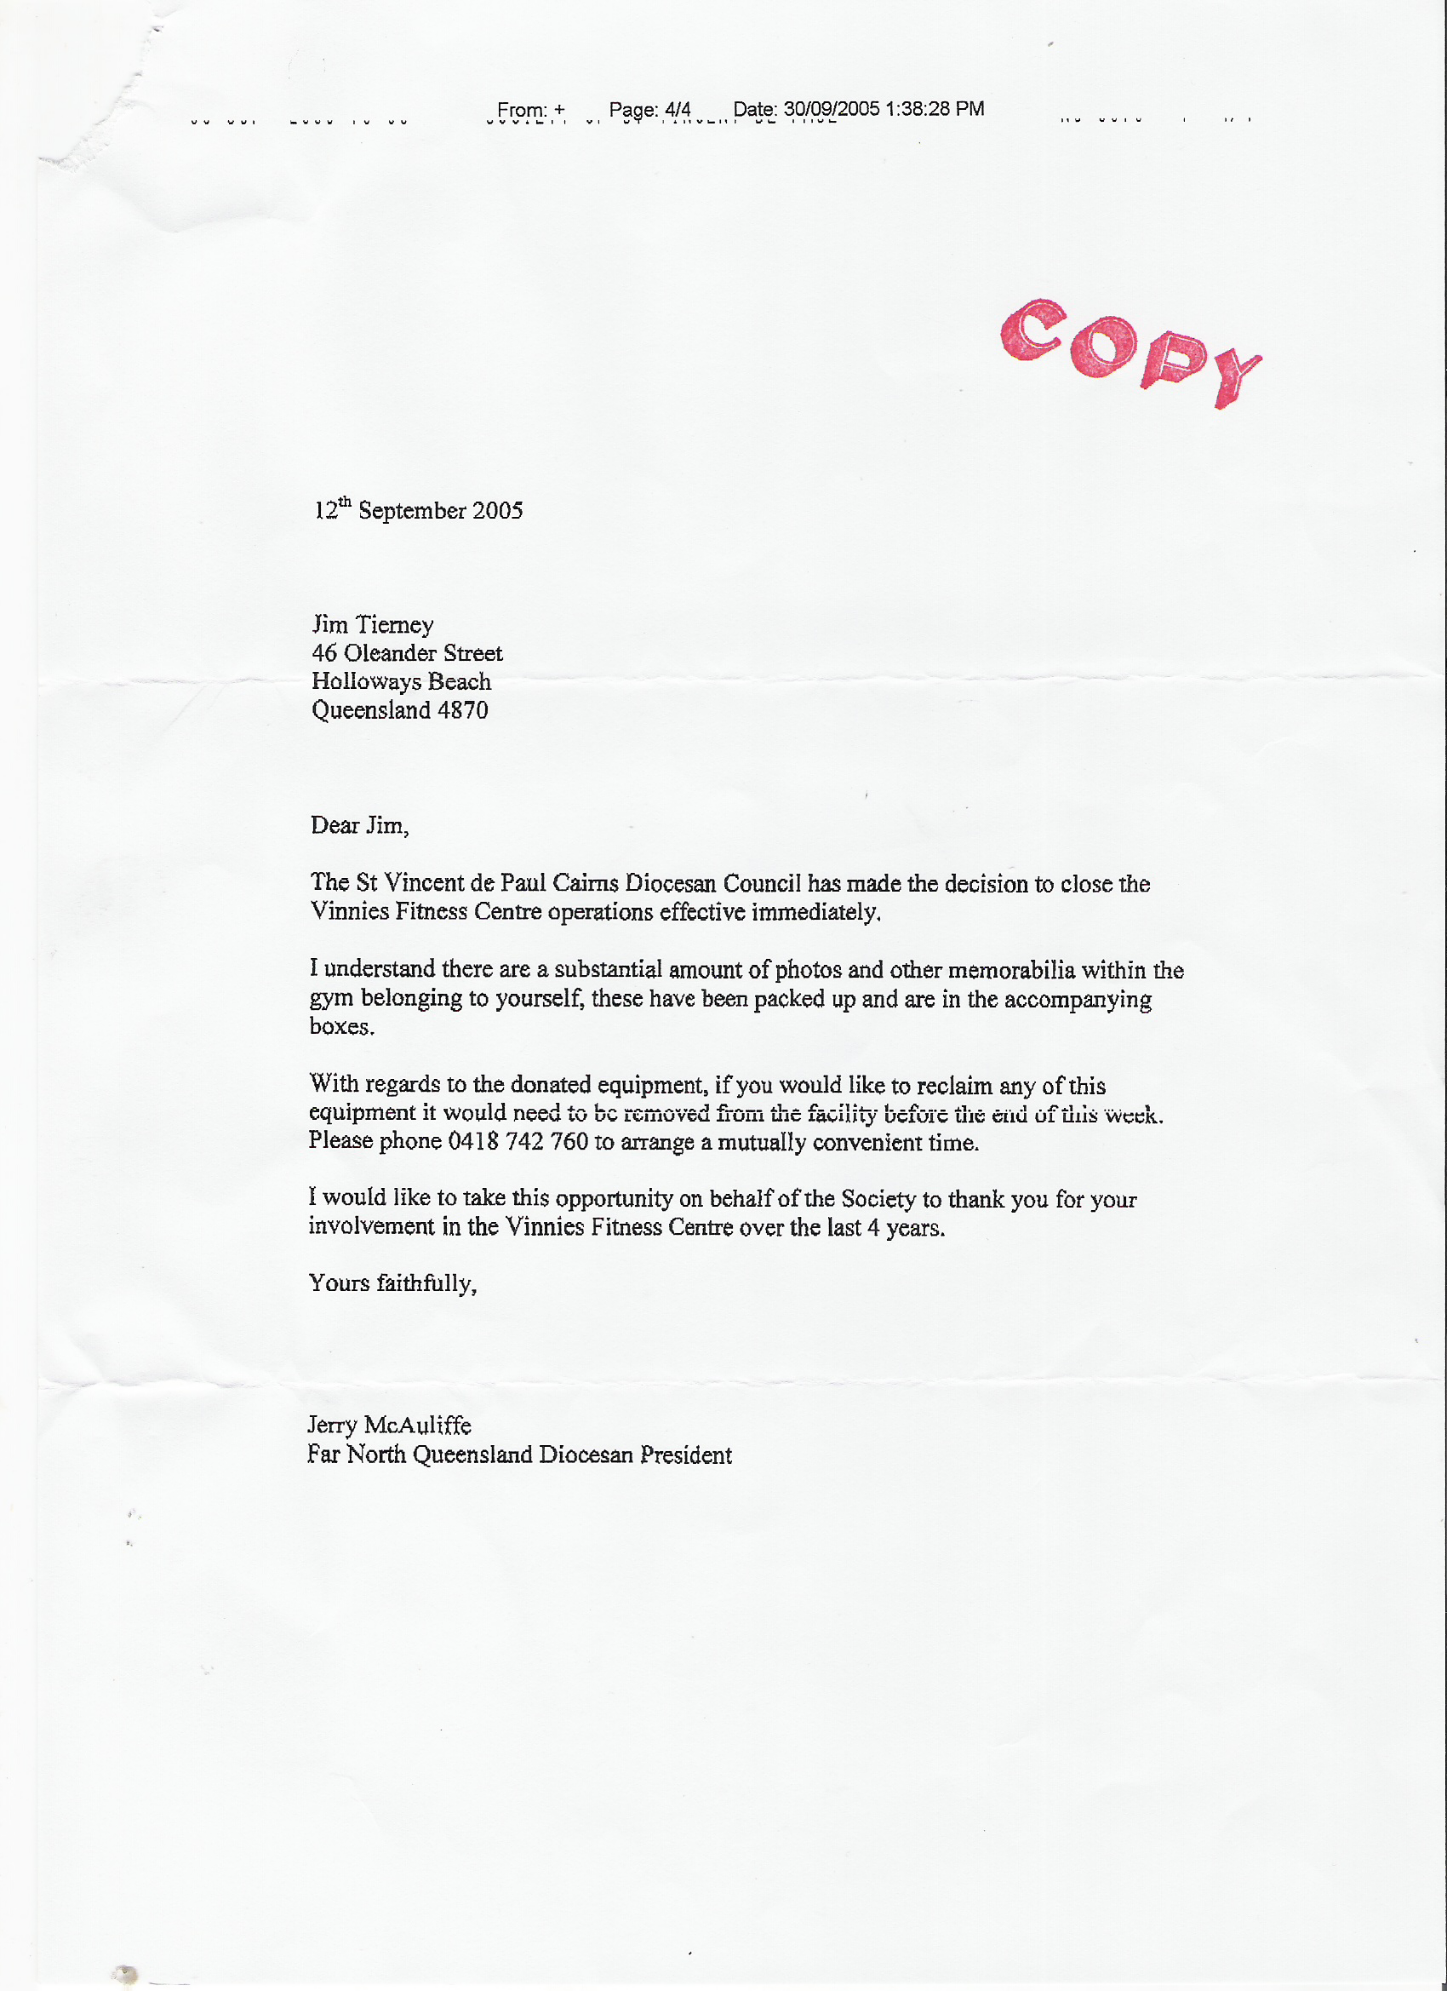

I HAD LOANED THESE PEOPLE VALUABLE BOXING PHOTOS THAT THEY REMOVED FROM THE WALLS WITH A CROW BAR. THESE GOOD CHRISTIAN PEOPLE CHANGED ALL THE LOCKS ON THE BUILDING. "The FNQ Diocesan Council should prepare an objective report by last week in October 2005 on the viability of this Gym beyond February 2006. This report will then be considered by State Council at its November meeting”.

●●●●●●●●●●●●●●●●●●●●●●●●●●●●●●●●●●●●●●●●●●●●●●
●●●●●●●●●●●●●●●●●●●●●●●●●●●●●●●●●●●●●●●●●●●●●●●

McAuliffe’s note arrived at my home in a box with my valuable photos smashed. It arrived on Tuesday 13th September 2005 stating I had to have all my equipment removed by Friday 16th September 2005. It took me months to erect all my equipment in that building I had no help from any of these individuals. And McAullife gave me three days to reclaim my equipment.

●●●●●●●●●●●●●●●●●●●●●●●●●●●●●●●●●●●●●●●●●●●●●●●
I JAMES V. TIERNEY HAVE CRONIC PTSD CAUSED BY A NEGLIGENT
PROCEEDURE IN A NSW HOSPITAL, AND HAVE BEEN UNDER PYSICHIATRIC CARE SINCE 1993 JUDY TIERNEY IS MY OFFICIAL CARER.
THESE INDIVIDUALS KNEW I DO NOT DRIVE. THESE DELIBERATE ANTAGONISTIC ACTIONS NOT ONLY INTENSIFIED MY CONDITION, BUT ALSO MADE MY CARER, MY WIFE JUDY TIERNEY HYSTERICAL.

On the day of the gym closing I had to call a friend of my wife and BISHOP James Foley a psychiatrist, Dr. Jeff Taylor. He advised me to call the C.A.T.T. Team out which I did. Then I rang SISTER Pam Thompson (Mersey nun) and St. Ann’s conference president Margaret Barlow. Fortunately for me they helped her.
My wife is my official carer can you imagine the condition I was in-if SISTER Pam (Mersey nun) had not helped my wife-
she said “if she had not witnessed it herself she would never have believed so called Christians could behave with such cruelty”.

ALL BECAUSE I WOULD NOT LET THE INSTRUCTORS FORGE INDIGENOUS NUMBERS!

Also on the day of the gym closing Byron Donnely SVDP Gym instructor said to the CEO Peter Maher “what are we going to do with our handicapped children because you cowardly B…………are leaving for Brisbane now-so you do not have to face the parents” his reply was
‘Life’s tough’ thankfully these words were witnessed by people.

CEO Maher told SVDP youth Coordinator Franine Kubanek to use STRATEGIES to handle the bullying from Administrator Mrs.Fell and McAuliffe.
This is when Francine thought she was going to Brisbane to cease Administrator Fell’s Bullying. How wrong she was.

McAuliffe said publicly, that no one involved in the gym, had gathered statistical information regarding the gym. {This was a feeble ploy to discredit the Stat Decs} EVERY individual that went to the gym had to sign a disclaimer form. That is the legal record for gym numbers. I told both the State president Mckeown and State Secetary Tom Barry in Brisbane, that you cannot put fraudulent figures down because they have to correspond with the disclaimer numbers. Barry said just guess! Read below!

●●●●●●●●●●●●●●●●●●●●●●●●●●●●●●●●●●●●●●●●●●●

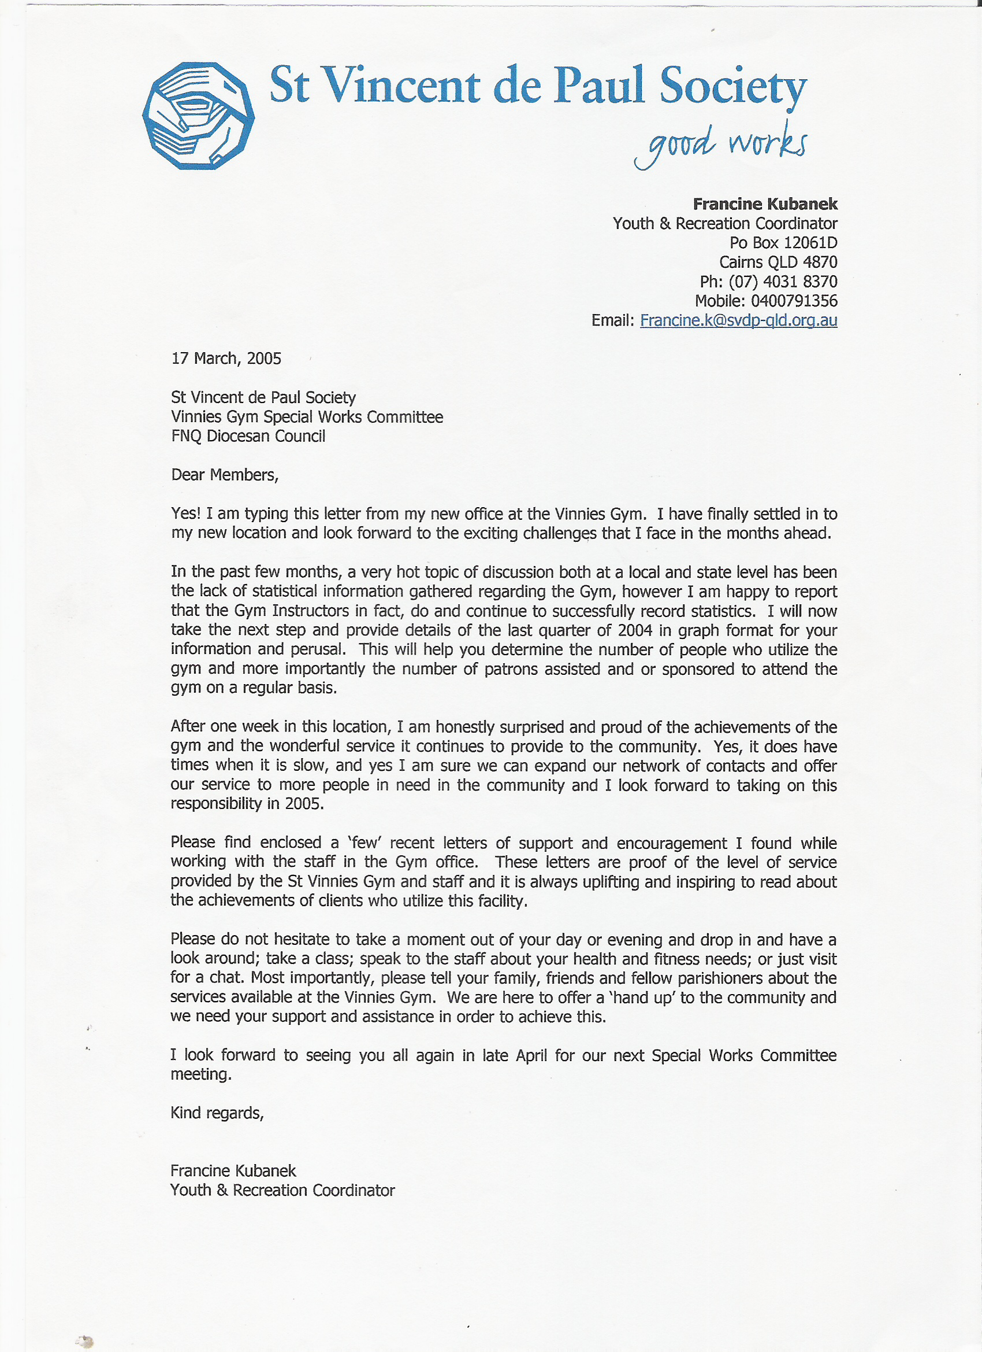
●●●●●●●●●●●●●●●●●●●●●●●●●●●●●●●●●●●●●●●●●●●

SVDP youth Coordinator Franine Kubanek --“However I am happy to report that the GYM INSTUCTORS in fact, do and continue to successfully record statistics”.
CEO Maher and McAuliffe show nothing but contempt for these people.

COPY

●●●●●●●●●●●●●●●●●●●●●●●●●●●●●●●●●●●●●●●●●●●●●●●

●●●●●●●●●●●●●●●●●●●●●●●●●●●●●●●●●●●●●●●●●●●●●●●
COPY
Judy Tierney following what she thinks is the correct way to resolve this nonsense by going over Maher’s head and telling the National president in Western Australia. 30 September 2005 10:55. WITH NO RESPONSE
COPY

COPY
●●●●●●●●●●●●●●●●●●●●●●●●●●●●●●●●●●●●●●●●●●●●●●●
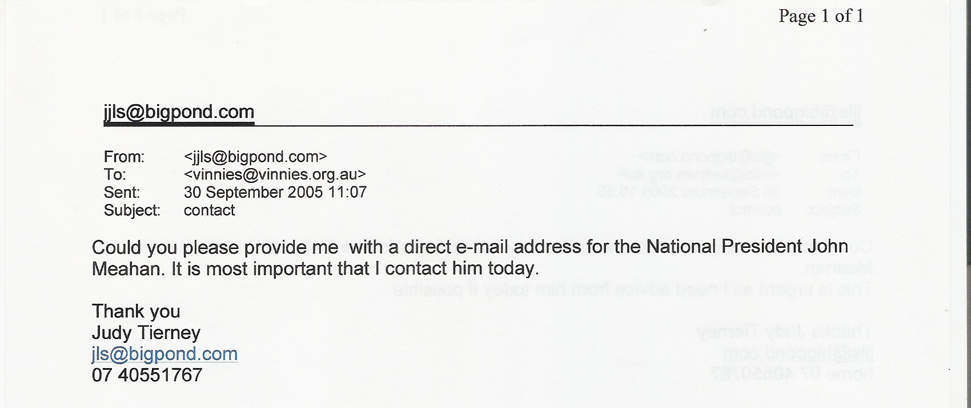

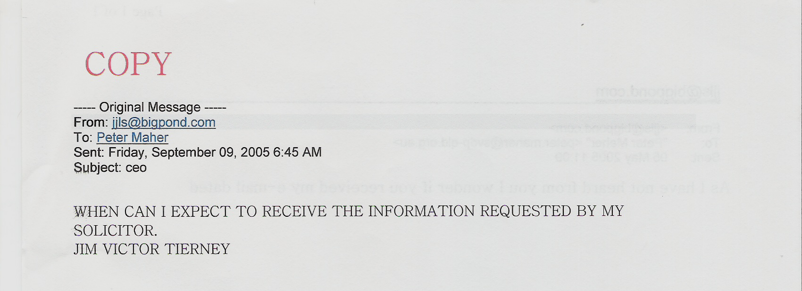
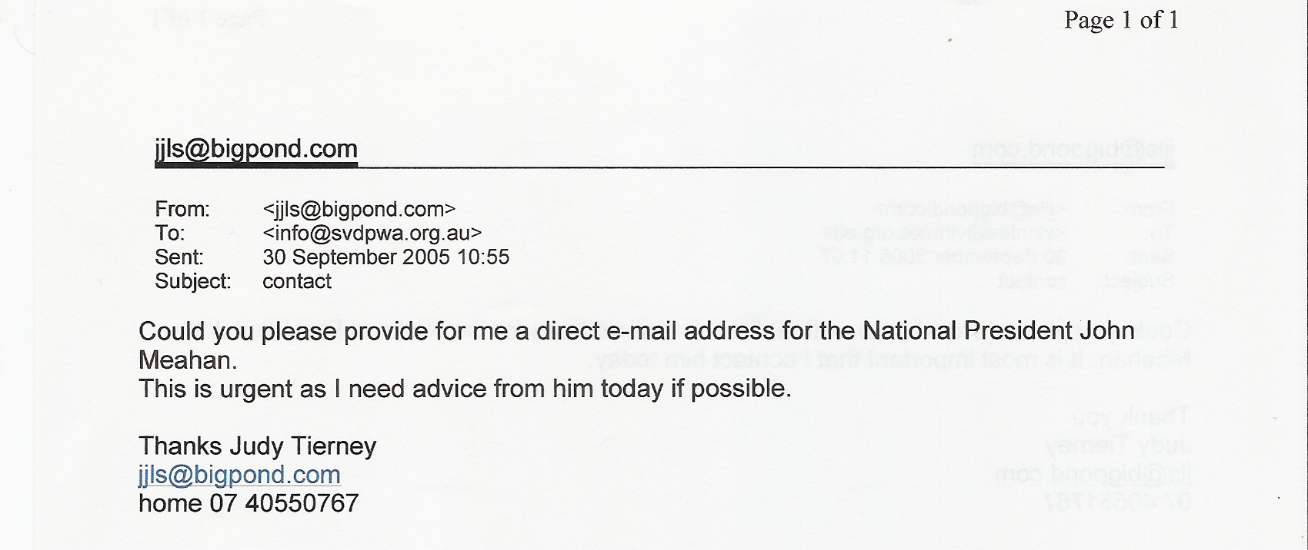
●●●●●●●●●●●●●●●●●●●●●●●●●●●●●●●●●●●●●●●●●●●●●●●
●●●●●●●●●●●●●●●●●●●●●●●●●●●●●●●●●●●●●●●●●●●●●●●

●●●●●●●●●●●●●●●●●●●●●●●●●●●●●●●●●●●●●●●●●●●●●●●
JIM TIERNEY Email TO STATE PRESIDENT MICHAEL MCKEOWN Friday, September 9

COPY

---- Original Message -----
From: jjls@bigpond.com
To: carolyn.sauvage@svdp-qld.org.au
Sent: Friday, September 09, 2005 8:42 AM
Subject: Attention State President Michael McKeown.

Michael I know you could not care less.
But just for the sake of my honour and so that you can never say you have not been told-my wife JUDE you’re once representative here in Cairns is extremely ill and I mean extremely. She has tried numerous times to ring you but it seems all phones in Brisbane do not reach Cairns anymore. A psychiatrist who fortunately is a good friend of both of us is supervising her.
She genuinely thought you would help her when help was needed, your lack of support has destroyed her faith and for that I hope you are proud.
I do not really expect a response, as I am sure you will follow the SVDP way of ignoring a problem in the eventuality it will just go away.

I also hope you remember why JUDE and I met with you and Mr. Barry in Brisbane.
But I assure you and your ceo I most certainly will not go away even if I have to take up the charitable offer from my friend a true man of GOD and a Barrister in Liverpool to visit me to help clear my name. As it seems to me solicitors in Australia just get ignored.

You where welcomed in my home whenever you where in Cairns and you just turned your back on JUDE. What makes it even harder to understand is when I first met you I asked you if you were in anyone’s pocket. Your answer was ‘I am my own man.’

As for me like Jesus Christ you and your ceo have tried to crucify me, humiliated me to an extent I hope you never have to feel.
You never even asked me what the conversation was about in the gym with Maree Fell and the president but everyone shortly will know.
I am going to ask you as the State President an alleged man of GOD to make your ceo send the clearly defined information requested by my solicitor to him. So I can conclude the process to clear my CATHOLIC NAME.

The Bishop wants to meet me shortly.
Ending on one last appeal could you return my book you have been asked to return on numerous occasions.

JAMES VICTOR TIERNEY COPY
●●●●●●●●●●●●●●●●●●●●●●●●●●●●●●●●●●●●●●●●●●●●●●●

●●●●●●●●●●●●●●●●●●●●●●●●●●●●●●●●●●●●●●●●●●●●●●●

NOW SVDP TRY INTIMIDATING ME, SECTION OF A LETTER FROM MY SOLITIORS

COPY

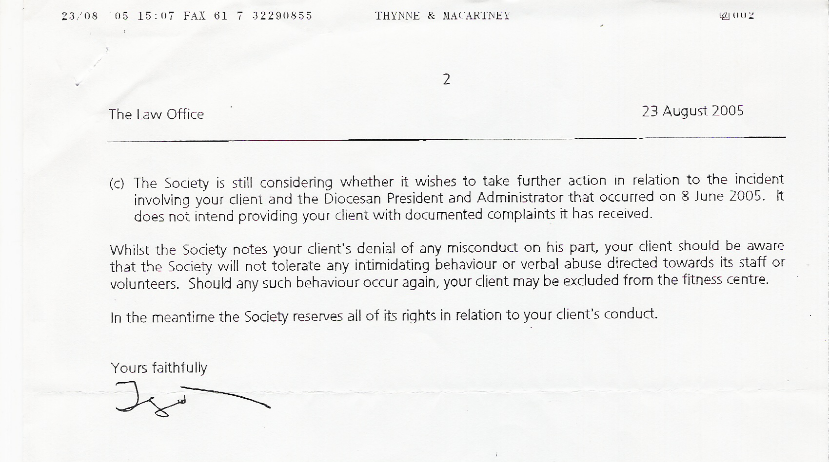

●●●●●●●●●●●●●●●●●●●●●●●●●●●●●●●●●●●●●●●●●●●

●●●●●●●●●●●●●●●●●●●●●●●●●●●●●●●●●●●●●●●●●●●●●●●

JIM TIERNEY- RESPONSE TO SVDP SOLICITORS AS CAN BE SEEN BY MY RESPONSE THESE SOLICITORS HELD ME IN CONTEMPT. AS I DID WITH THEM.
COPY
Dear Mr.

Thank you for KIND letter dated 3 October 2005.
First of all let me inform you kind people that part of MY PROPERTY has been stolen. The custodians (‘the society’) of my property changed all the locks in which MY PROPERTY was being held being good Christians that they are. So the Custodians (‘the society’) being the keeper of keys of the building had the only access to the building in which- as you so rightly put it MY PROPERTY was stored.
Have them return MY PROPERTY without more ado. I think (‘the society’) your client have not realised they have more of MY PROPERTY in Ravenshoe and Mareebra please inform maher I want this property returned to me also as soon as possible. I must applaud you people educating maher who should now know the difference between correct registered mail and his form of pseudo registered mail it may save him some embarrassment in the future with him being a ceo.

JAMES VICTOR TIERNEY.

●●●●●●●●●●●●●●●●●●●●●●●●●●●●●●●●●●●●●●●●●●●●●●●

JUDY TIERNEY- LETTER TO SVDP SOLICITOR AFTER TRYING NUMEROUS TIMES FOR KEYS
FROM McAuliffe and ADMINISTATOR Fell. COPY

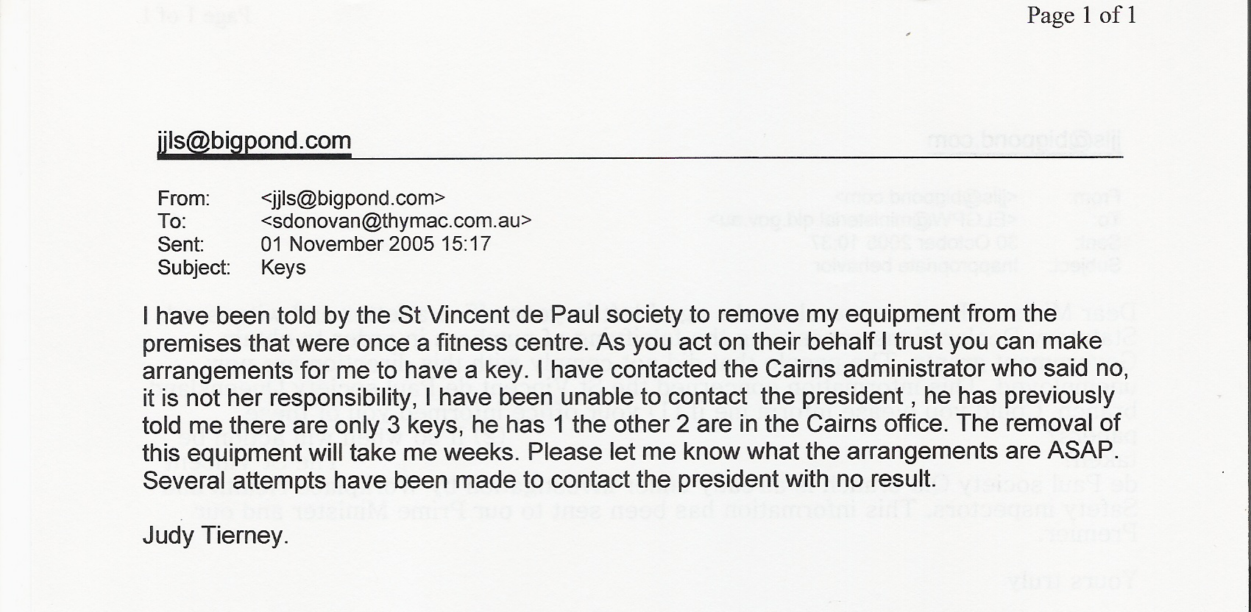

●●●●●●●●●●●●●●●●●●●●●●●●●●●●●●●●●●●●●●●●●●●●●●●

●●●●●●●●●●●●●●●●●●●●●●●●●●●●●●●●●●●●●●●●●●●●●●●
THE GAMES PEOPLE PLAY-SVDP SOLICITORS SHOWING MORE CONTEMPT TO MY WIFE JUDY TIERNEY

From: Shane Donovan
Date: 07 November 2005 14:03
To: jjls@bigpond.com
Subject: RE: Gymnasium Equipment
-----------------------------------------------------------------------------------------------------------------
COPY
Dear Mrs Tierney,

The letter attached to my email was sent to you by post on 3 November 2005. I trust that you will receive it shortly (assuming you haven't already received it by now).

Regards
_____________________
Shane Donovan
Associate
T: +61 7 3231 8832 F: +61 7 3229 0855
THYNNE & MACARTNEY
Member of the Kennedy Strang Legal Group
Level 27, Comalco Place
12 Creek Street, Brisbane QLD 4000
www.thymac.com.au
----------------------------------------------------------------------------------------------------------------------------------
-----Original Message----- COPY
From: jjls@bigpond.com
Sent: Thursday, 3 November 2005 9:10 AM
To: Shane Donovan
Subject: Re: Gymnasium Equipment
Your e-mail arrived this AM, however I am unable to open it, so still have no idea of your response.

Judy Tierney

------------------------------------------------

COPY
----- Original Message -----
From: Shane Donovan
To: jjls@bigpond.com
Sent: Wednesday, November 02, 2005 7:16 PM
Subject: Gymnasium Equipment

Please see attached letter.
Regards
_____________________
Shane Donovan
Associate
T: +61 7 3231 8832 F: +61 7 3229 0855
THYNNE & MACARTNEY
Member of the Kennedy Strang Legal Group
Level 27, Comalco Place
12 Creek Street, Brisbane QLD 4000
www.thymac.com.au
<<Thynne & Macartney 021105.pdf>>

IMPORTANT - This email and any attachments may be confidential and privileged. If received in error, please contact us and delete all copies. You should not rely on this message unless it is subsequently confirmed by another method of communication and signed by Thynne & Macartney. Before opening or using attachments, check them for viruses and defects.

No virus found in this incoming message.
Checked by AVG Free Edition.
Version: 7.1.362 / Virus Database: 267.12.7/154 - Release Date: 01/11/2005

IMPORTANT - This email and any attachments may be confidential and privileged. If received in error, please contact us and delete all copies. You should not rely on this message unless it is subsequently confirmed by another method of communication and signed by Thynne & Macartney. Before opening or using attachments, check them for viruses and defects.

No virus found in this incoming message.
Checked by AVG Free Edition.
Version: 7.1.362 / Virus Database: 267.12.8/161 - Release Date: 03/11/2005

COPY

●●●●●●●●●●●●●●●●●●●●●●●●●●●●●●●●●●●●●●●●●●●●●●●

●●●●●●●●●●●●●●●●●●●●●●●●●●●●●●●●●●●●●●●●●●●●●●●

SVDP REJECTS YOUR ASSERTION THAT THE EQUIPMENT IS YOUR PROPERTY
COPY

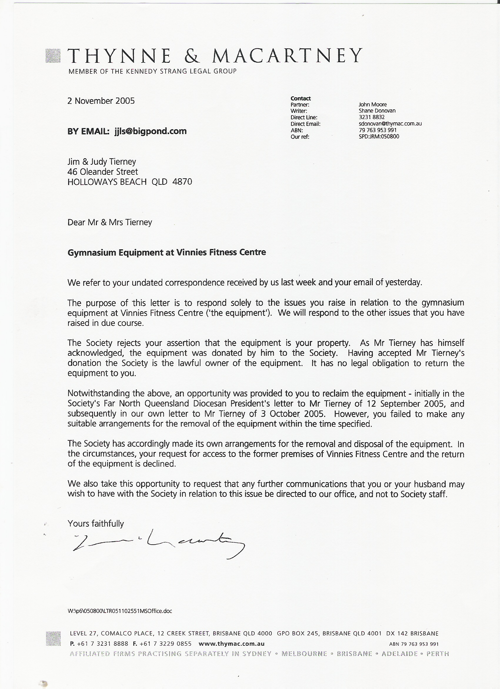
●●●●●●●●●●●●●●●●●●●●●●●●●●●●●●●●●●●●●●●●●●●●●●●

●●●●●●●●●●●●●●●●●●●●●●●●●●●●●●●●●●●●●●●●●●

Judy Tierney replies to CEO Maher.

From: jjls@bigpond.com
To Peter Maher
Sent: Saturday, 7 May 2005 7:04 PM COPY
Subject re e.mail

Dear Peter,
I have just read your return e.mail to Jim. One or two comments. As you know, change just for change sake, or change for point scoring, is never productive. The issue that this refers to, namely the old wares, is a product of both, with more emphasise on the second. The facts remain that this activity was without any consultation unceremoniously taken from me, and given to another volunteer who neither wished it or has the knowledge involved. As for Jim and I being given any regard in this dioceses you are wrong. With one or two exceptions any thanks or acknowledgment comes from those we assist. What I am going to say now relates to this area but I am sure would be found in all areas especially country ones. Unless someone, as in someone with some authority, is constantly at the hub of activities you only get to see or hear what the controlling person wishes you to see or hear, the Gold Coast is a good example. Vincentians and volunteers are at a disadvantage if they have concerns within their areas, if those concerns involve someone who sees themselves as in charge, who do they speak with? The Society within the Cairns area doesn't at this time have a very good name. The only two activities that generate any interest are the old wares and the Gym, neither of which receive support and in fact are constantly being undermined by various factions. Maybe your comment regarding change should be discussed with those who don't wish to see any change within the Society; especially any change that might offer assistance to those marginalised groups the Society was formed to help. This is not a happy place just now to the extent that some volunteers are asking themselves, why do I put up with this? I know of two people who, when asking about volunteer work have been told to do it anywhere but with the Society. Being a forgiving person is one thing, but being taken for granted or insulted is another, if someone has a forgiving nature that can often be taken as a licence for others to be rude or insulting. I am sure you would not like to be insulted in such a manner.

Judy

●●●●●●●●●●●●●●●●●●●●●●●●●●●●●●●●●●●●●●●●●●●●●●●

●●●●●●●●●●●●●●●●●●●●●●●●●●●●●●●●●●●●●●●●●●●●●●●
CEO MAHER’s STRATEGIES did not work; they stood by and let this kid get abused till she could take it no more. MISSION ACCOMPLISHED DIGNIFIED TO THE END.

COPY

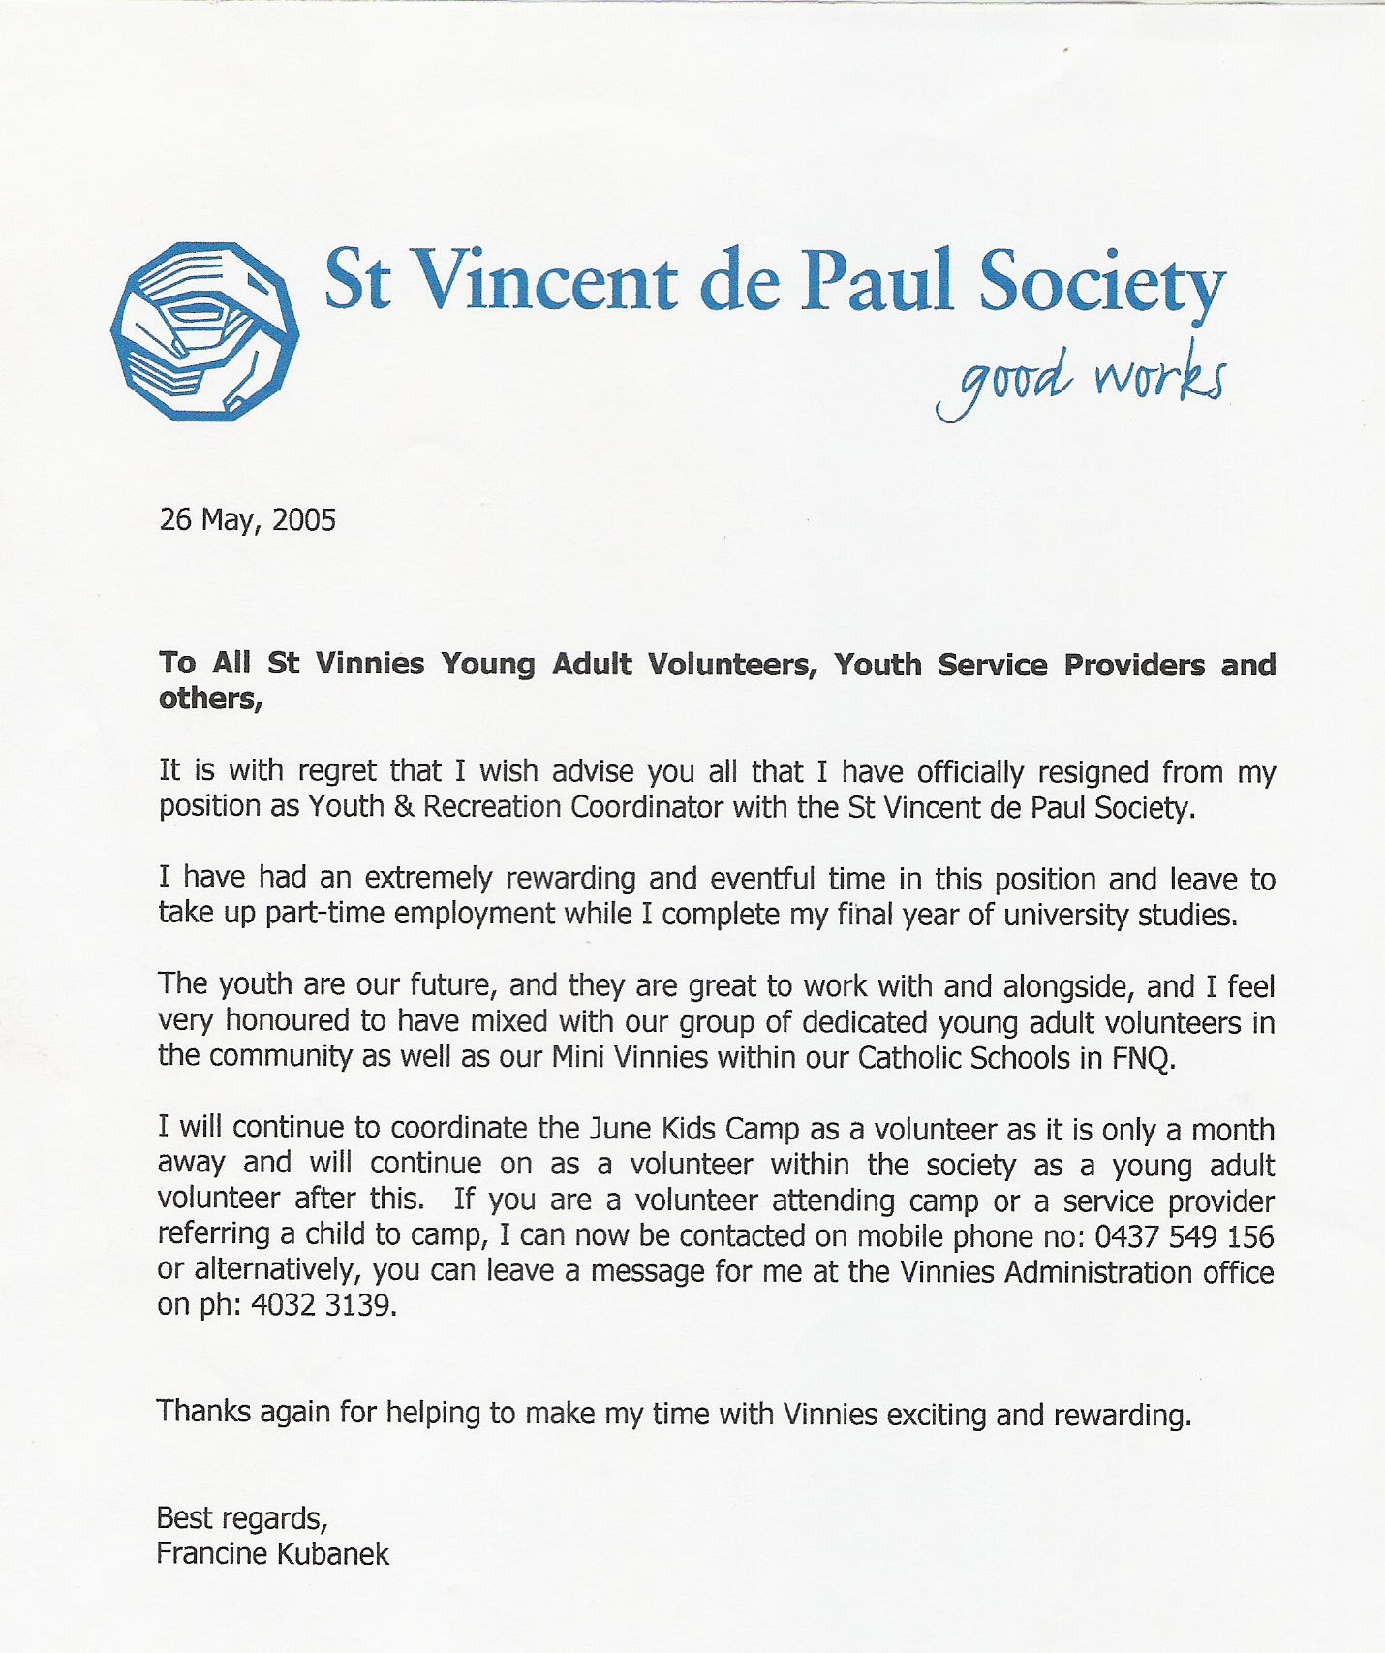

●●●●●●●●●●●●●●●●●●●●●●●●●●●●●●●●●●●●●●●●●●●●●●●

●●●●●●●●●●●●●●●●●●●●●●●●●●●●●●●●●●●●●●●●●●●●●●●

THIS IS WHEN JUDY TIERNEY AND JIM TIERNEY REALISED THAT MAHER, FELL and McAULIFFE, WANTED ME [JIM TIERNEY] OUT SO I ASKED FOR HELP FROM SOME OF THE OLD MEMBERS. COPY
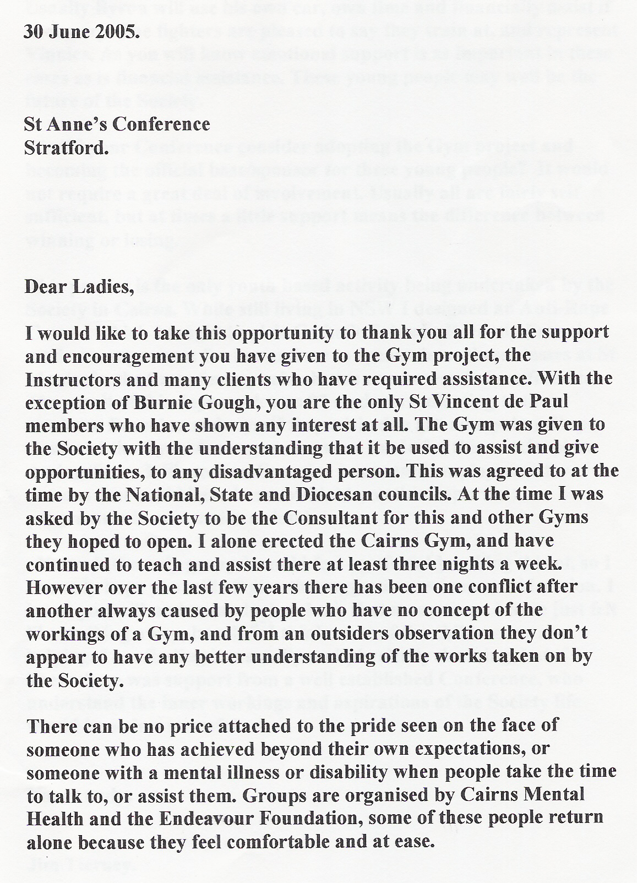

COPY
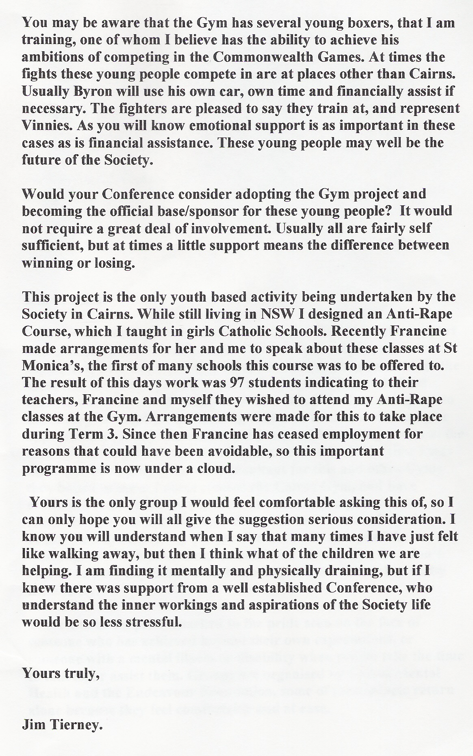

●●●●●●●●●●●●●●●●●●●●●●●●●●●●●●●●●●●●●●●●●●●●●●●

●●●●●●●●●●●●●●●●●●●●●●●●●●●●●●●●●●●●●●●●●●●●●●● I, JIM TIERNEY, WAS TRYING TO CONTACT JUDY’S FRIEND DR. JEFF TAYLOR PSYCHIATRIST. I COULD NOT WORK OUT AT THE TIME, HOW TO SEND AN ATTACHMENT BECAUSE MY ANXIETY LEVELS HAD INCREASDED THAT MUCH. I WAS SO CONCERNED ABOUT MY WIFE.
JEFF TAYLOR PSYCHIATRIST.

COPY
From: jjls@bigpond.com
To: Chris & Jeff Taylor
Sent:

Subject: JUDY

Dear Jeff-forgive all the writing my head cannot work out to send it any other way. These people have wanted to make Tony the boys and I for years put down fraudulent numbers of Indigenous people to acquire Government Grants. Jude is on the verge of having a nervous breakdown!
This friend of the ceo of svdp summoned Jude his words- to be interviewed at the gym. He finished off by telling her I did not give to the charity the whole gym-just bits of it.
I will include Francine's resignation letter- at the time she put this to paper she was still going to run the kids camp's.
She had already left her job and bumped into MAREE FELL who abused her publicly again so as always the POOR KIDS miss out again.

Jeff I think you need to know what is really happening you can tell as many people the real reason they have barred me from the gym- they are playing a number on me.

COPY
●●●●●●●●●●●●●●●●●●●●●●●●●●●●●●●●●●●●●●●●●●●●●●●

JIM TIERNEY SENT TO Dr. JEFF TAYLOR PSYCHIATRIST. COPY

----- Original Message -----
From: jjls@bigpond.com
To: Chris & Jeff Taylor
Sent:
Subject: JUDY

Dear Jeff
Judy has- ON HER OWN for four years been storing from svdp-old wares and collectables, washing literally thousands of garments (HER MONEY) polishing thousands of spoons ect. To help the poor in her own way. She was raising 3 to 4 grand each sale. She was told by e-mail she was not to do this anymore. Actually it was me who had to tell her. Maree Fell and the Diocesan President made this decision without even telling her to her face. Fell told the Ladies Judy said she did not want to do this anymore-WHICH SENT JUDE RIGHT OFF --SHE HAS BEEN SOBBING because she said nothing at all about stopping. Fell bullied the life out of the new Youth Officer who resigned because of her bullying. I Spent days talking with the Youth Officer I had 97 young girls the (third course) from St Jacks booked in to do my Anti-rape course (free of course) that Fell has now destroyed.
I am REALLY WORRIED OVER JUDE I THINK SHE IS ON THE EDGE OF A BREAK DOWN-JEFF could you possibly ring her tomorrow and talk to her she has always been so fond and trusting of you. I would not ask you only I am so scared about her behaviour.

JIM.
COPY

●●●●●●●●●●●●●●●●●●●●●●●●●●●●●●●●●●●●●●●●●●●●●●●
JEFF TAYLOR PSYCHIATRIST.

COPY
----- Original Message -----
From: Chris & Jeff Taylor
To: Jimmy & Judy Tierney
Sent: Saturday, September 10, 2005 11:27 PM
Subject: Keeping In Touch

Hi Judy,
Are you getting any assistance up there in Cairns? In relation to the matters aired in our last conversation, I would like to have a yarn with you over the phone again soon
Regards,
Jeff Taylor

No virus found in this incoming message.
Checked by AVG Anti-Virus. Version: 7.0.344 / Virus Database: 267.10.20/95 - Release Date: 9/09/2005

●●●●●●●●●●●●●●●●●●●●●●●●●●●●●●●●●●●●●●●●●●●●●●●
JUDY TIERNEY SENDS Email TO Dr. JEFF TAYLOR PSYCHIATRIST.

COPY
----- Original Message -----
From: jjls@bigpond.com
To: Chris & Jeff Taylor
Sent: Wednesday, October 12, 2005 7:50 PM
Subject: health

Dear Chris & Jeff,
Thanks for your support, I am much better, not as well as I soon hope to be, but getting there. I spoke again last week with Bishop James, he asked after you both. Hope you are both well. I'll be in contact again soon.
Love Judy

No virus found in this outgoing message.
Checked by AVG Anti-Virus.
Version: 7.0.344 / Virus Database: 267.11.13/124 - Release Date: 07/10/2005

●●●●●●●●●●●●●●●●●●●●●●●●●●●●●●●●●●●●●●●●●●●●●●●

●●●●●●●●●●●●●●●●●●●●●●●●●●●●●●●●●●●●●●●●●●●●●●●

DR. JEFF TAYLOR PSYCHIATRIC TO JUDY TIERNEY

COPY

From: Chris & Jeff Taylor
Date: 15 October 2005 21:33
To: jjls@bigpond.com
Subject: Re: Keeping In Touch

Good to hear from you. I am please that you have been able to access some local assistance.

Take care & best wishes to you, Jimmy et al.

Regards,

Jeff Taylor

COPY

●●●●●●●●●●●●●●●●●●●●●●●●●●●●●●●●●●●●●●●●●●●●●●●

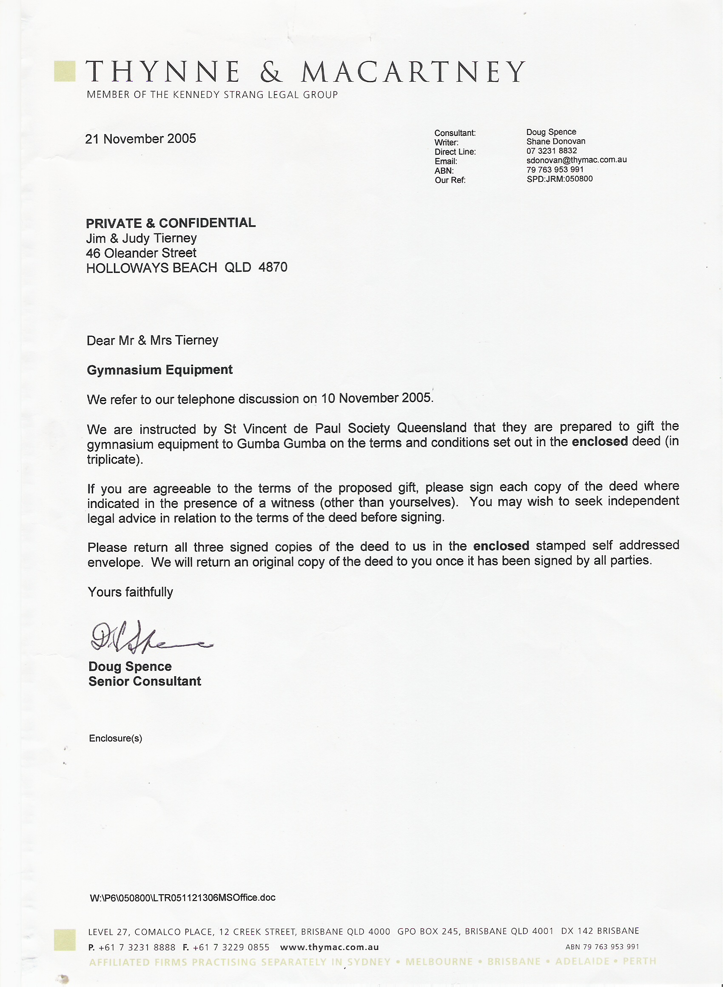
●●●●●●●●●●●●●●●●●●●●●●●●●●●●●●●●●●●●●●●●●●●●●●●
Below-- this is a letter from SVDP brief saying it is not our (Judy /Jim Tierney) equipment. But if Judy and me signed the gagging document that came with it, they will gift the equipment to some else.
“If you are agreeable to the terms of the proposed gift……….in the presense of a witness (other than yourselves). “You may wish to seek independent legal advice……………”

We Judy/Jim Tierney sent all the documents back to them with a note that said, “WE DECLINE YOUR NONSENSE”

Now QLD Branch of SVDP wants to gift our equipment to an indigenous group.
They realise we are not going to stop telling the appropriate people about their despicable behaviour. Imagine the headlines they would get in the local press. “SVDP GIFTS AN INDIGENOUS GROUP A WHOLE FITNESS CENTRE”. IN ONE SIGNING OF A GAGGING ORDERS SVDP WALK! COPY
●●●●●●●●●●●●●●●●●●●●●●●●●●●●●●●●●●●●●●●●●●●●●●●
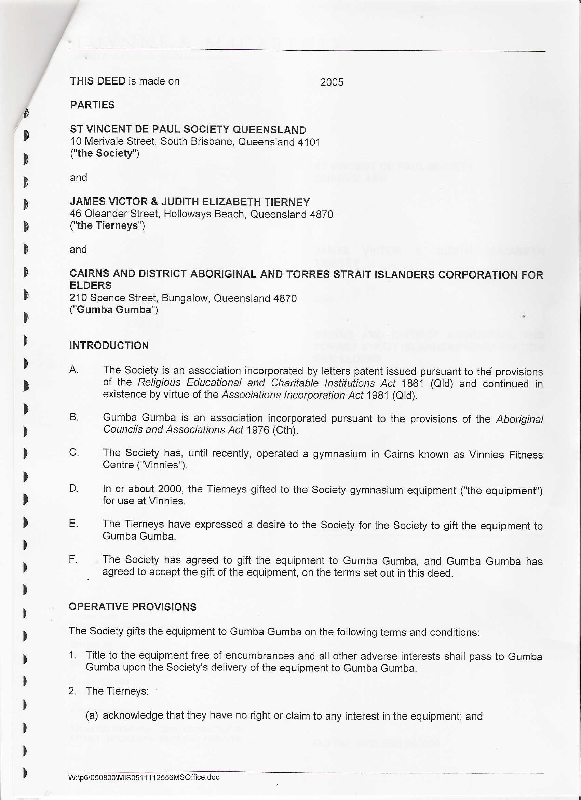
Judy and Jim Tierney received one each of the documents below. Encumbrances= nuisance
Adverse = harmful
Interests= comfort BULLIES HATE PEOPLE THAT STAND UP AND FRONT THEM. COPY ONE GAGGING ORDER BELOW

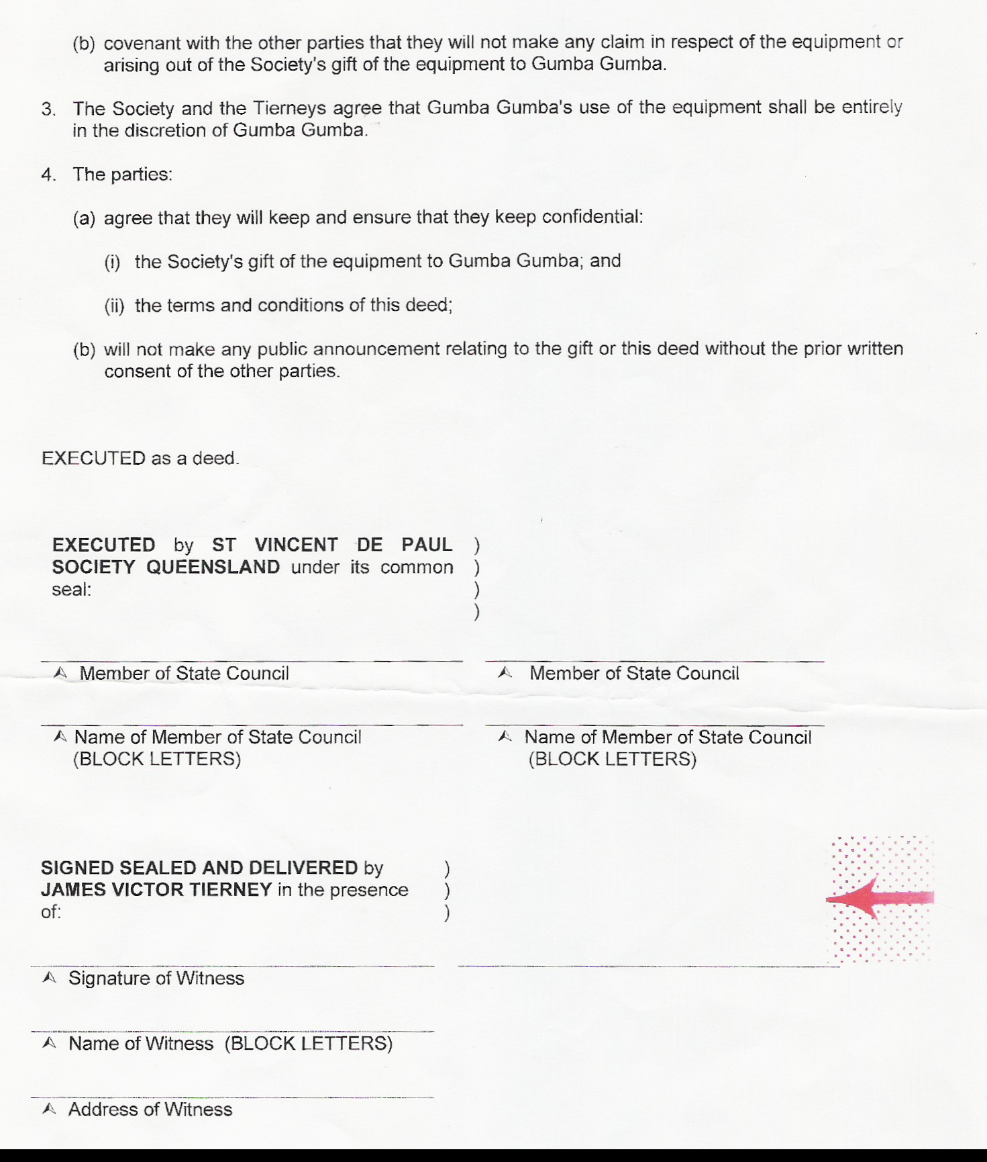
●●●●●●●●●●●●●●●●●●●●●●●●●●●●●●●●●●●●●●●●●●●●●●●

●●●●●●●●●●●●●●●●●●●●●●●●●●●●●●●●●●●●●●●●●●●●●●●

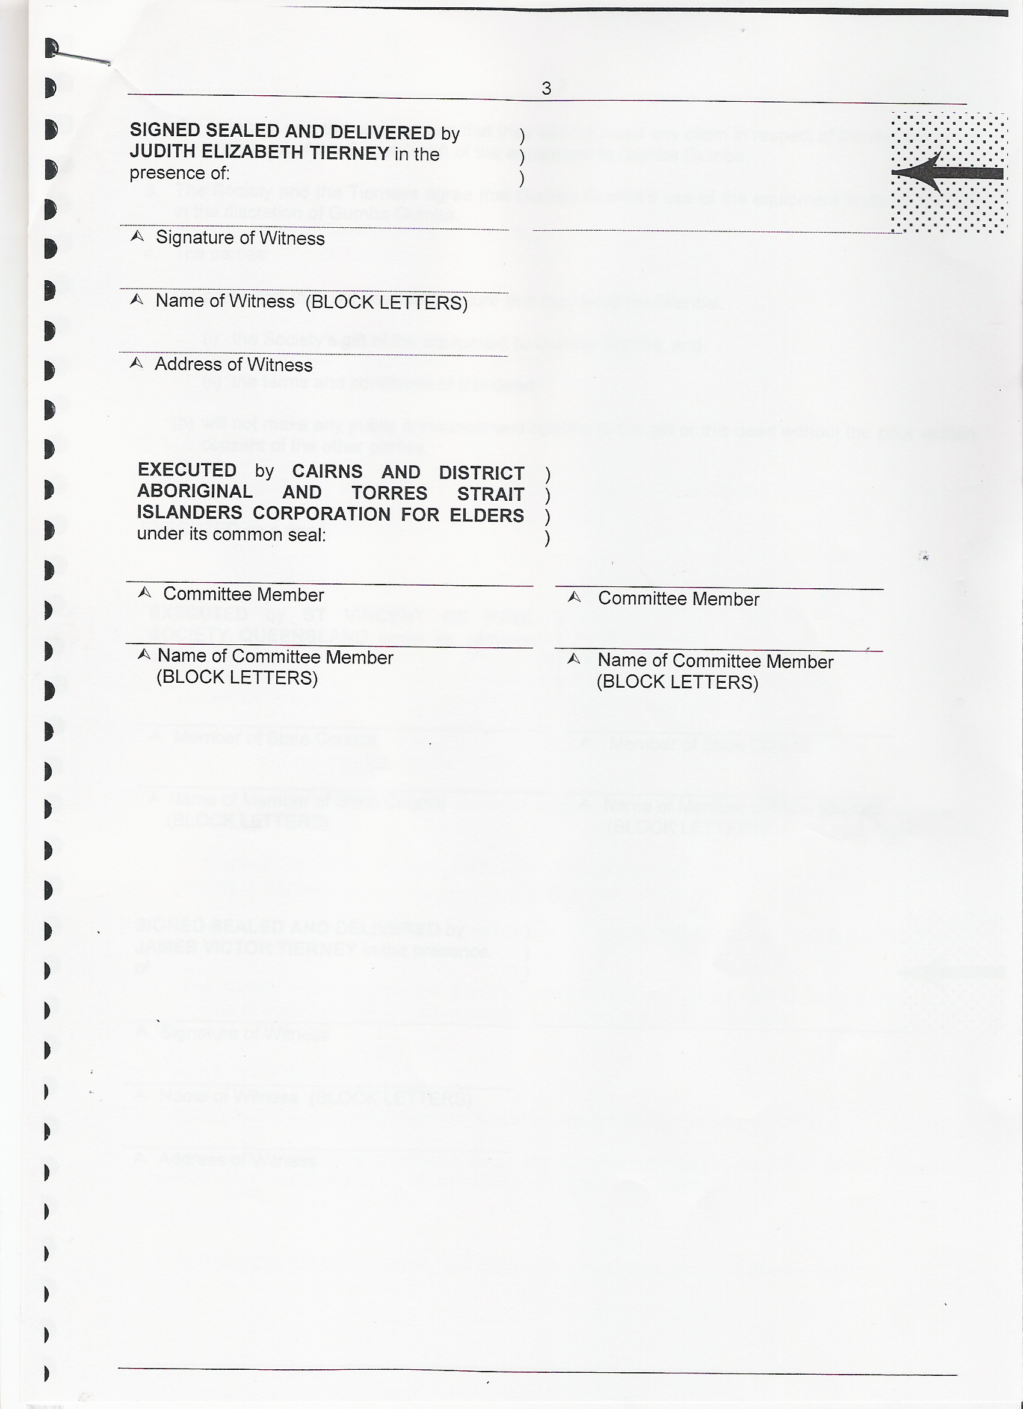
SECOND GAGGING ORDER BELOW
COPY

●●●●●●●●●●●●●●●●●●●●●●●●●●●●●●●●●●●●●●●●●●●●●●●

●●●●●●●●●●●●●●●●●●●●●●●●●●●●●●●●●●●●●●●●●●●●●●●
SVDP SOLICITORS HAVE TORMENTED MY WIFE AND ME, HUMILIATED US BOTH, CALLED US LIERS, REPEATED TOLD US THE EQUIPMENT WAS DONATATED TO SVDP UNCONDITIONAL, NOW SVDP WANT TO GIFE OUR EQUIPMENT TO ANOTHER PARTY BUT ONLY IF WE SIGN GAGGING ORDERS-- PLEASE! COPY
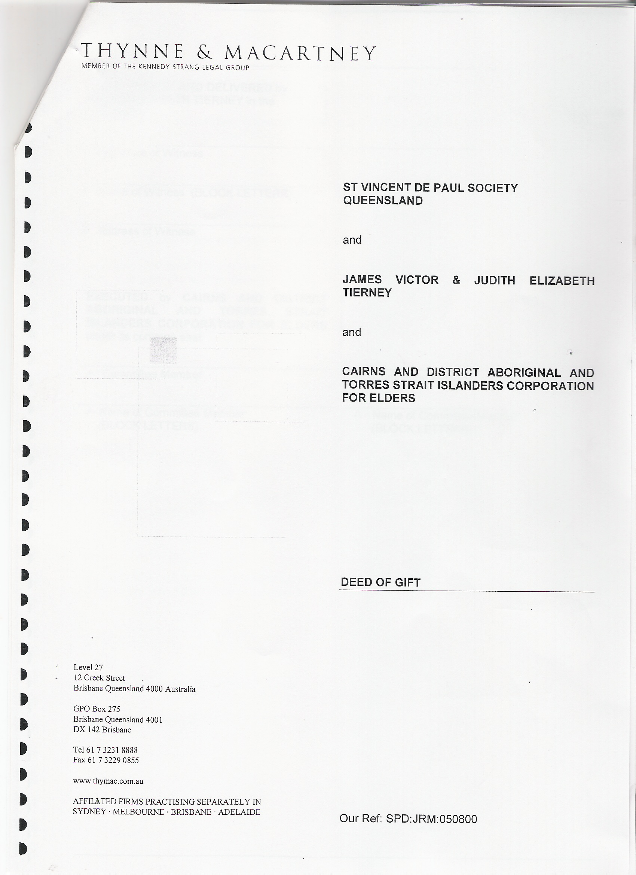
●●●●●●●●●●●●●●●●●●●●●●●●●●●●●●●●●●●●●●●●●●●●●●●

JUDY JIM TIERNEY--- WE DECLINE YOUR NONSENSE

●●●●●●●●●●●●●●●●●●●●●●●●●●●●●●●●●●●●●●●●●●●●●●●

●●●●●●●●●●●●●●●●●●●●●●●●●●●●●●●●●●●●●●●●●●●●●●●

COPY
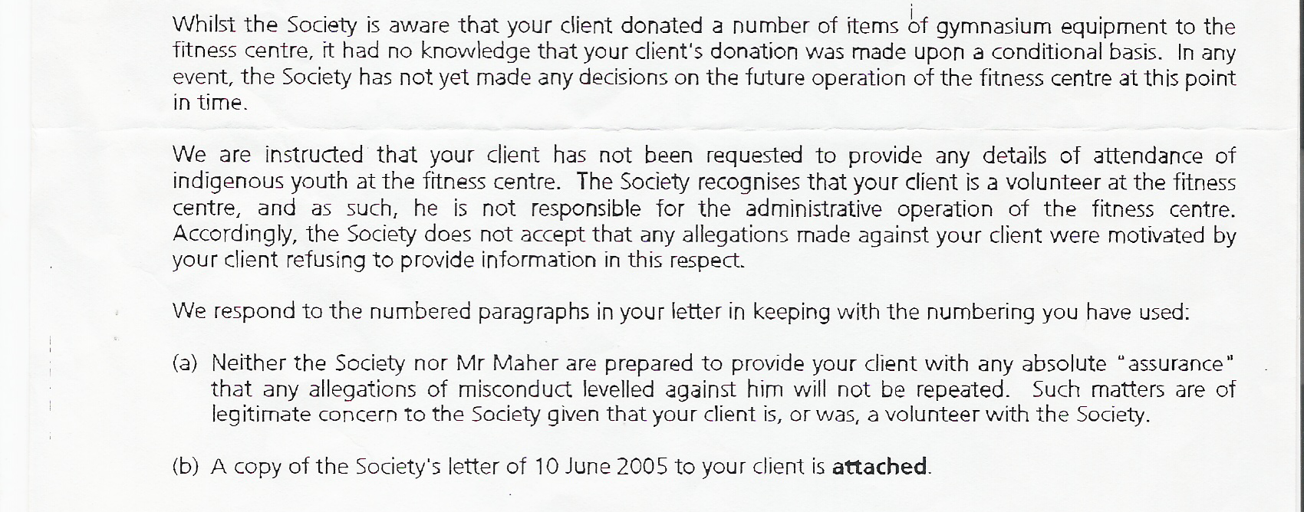

COPY

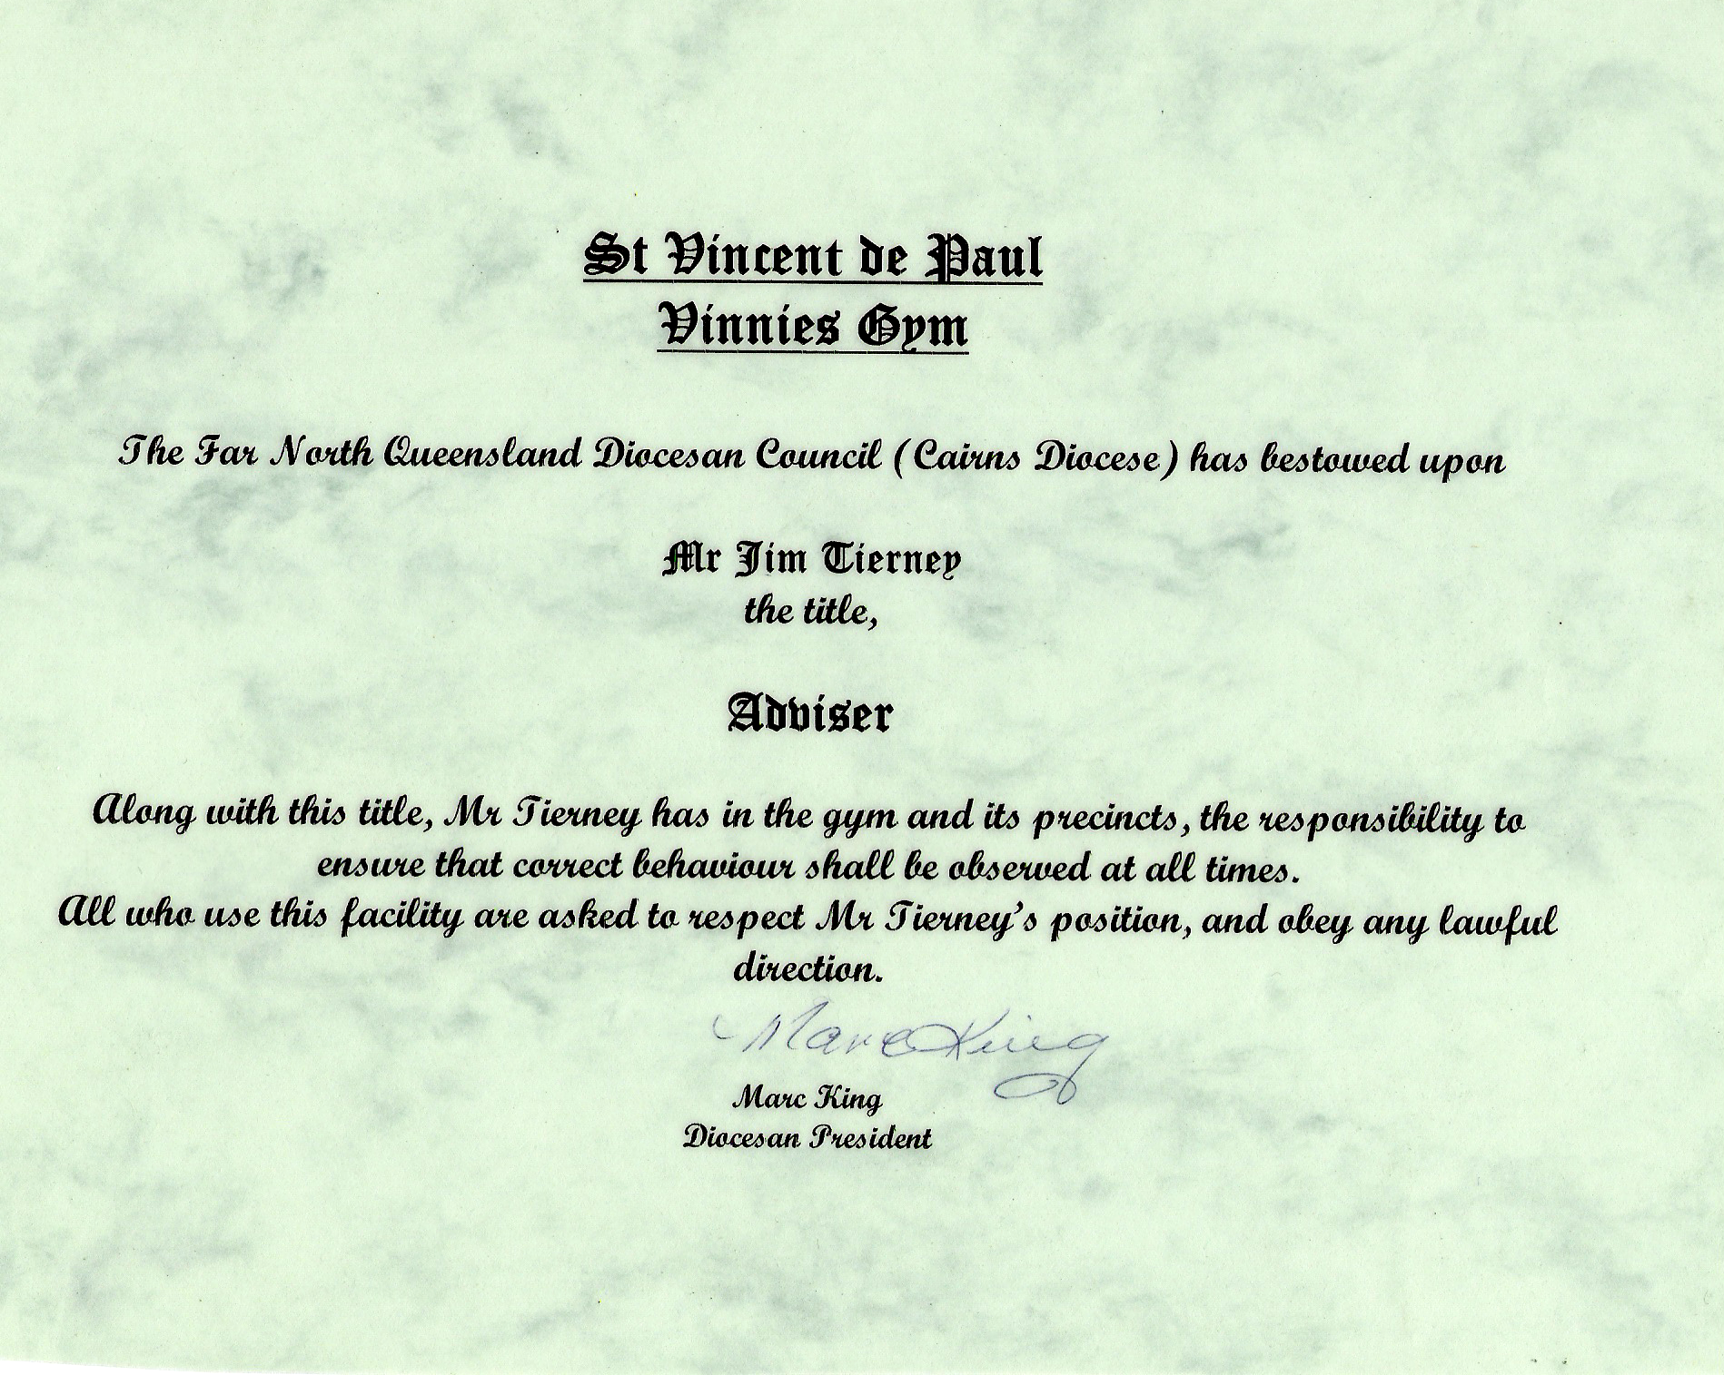
●●●●●●●●●●●●●●●●●●●●●●●●●●●●●●●●●●●●●●●●●●●●●●●

●●●●●●●●●●●●●●●●●●●●●●●●●●●●●●●●●●●●●●●●●●●●●●●

COPY
THYNNE & MACARTNEY
MEMBER OF THE KENNEDY STRANG LEGAL GROUP

13 December 2005 Partner. Frank Tuner
Writer. Shane Donovan
Direct Line 07 3231 8832
Email: sdonovan@thymac.com.au
ABN: 79 763 953 991
Our Ref: SPD: RKL: 62117

Jim & Judy Tierney
46 Oleander Street
HOLLOW A YS BEACH QLD 4870

Dear Mr & Mrs Tierney

Gymnasium Equipment

The purpose of this letter is to let you know that, in light of your response to our letter of 21 November
2005, it is the Society's intention to make its own arrangements for the disposal of the gymnasium equipment.

As we have previously indicated to you, the Society rejects your assertions that the equipment is your
property. It was donated to the Society by Mr Tierney. Upon accepting the donation the Society
became the lawful owner of the equipment. As the lawful owner of the equipment the Society enjoys the right to dispose of the equipment as it sees fit. Though it is not required to consult with you or seek
your approval prior to disposing of the equipment, it did so in this instance out of courtesy and as a
sign of good faith.

The Society now considers this issue to be closed.

Yours faithfully
Frank Turner

Partner

COPY
………………………………………………………………………………
JUDY JIM TIERNEY--- WE DECLINE YOUR NONSENSE

●●●●●●●●●●●●●●●●●●●●●●●●●●●●●●●●●●●●●●●●●●●●●●●

●●●●●●●●●●●●●●●●●●●●●●●●●●●●●●●●●●●●●●●●●●

JIM TIERNEY TO SVDP SOLICITORS COPY JAMES V. TIERNEY

Mr. Turner
PARTNER.
I gave to the Society of St. Vincent de Paul all equipment to establish a Fitness and Boxing facility. I gave this equipment on the CONDITIONAL UNDERSTANDING, that it would be used for the poor and disadvantaged BY THE SOCIETY!
I did not give it to your employers to dispose of it as they wished! I GAVE IT TO THEM TO ESTABLISH A FITNESS AND BOXING FACILITY FOR THE DISADVANTAGED AND POOR THAT THEY NOW HAVE CLOSED. SO RETURN MY EQUIPMENT BACK. As well as my donated equipment your employers have my personal equipment that I used to train the poor kids with. They also have equipment that my wife received from various businesses here in Cairns, FOR THE GYM, not your employers to give away. These people are still asking of my wife where their equipment is stored.
To confirm the actual conditions of my donation as witnessed by my wife Judith, who was the SVDP Cairns diocesan president at the time, and let me reassure you the Bishop knows does not lie. The person who also witnessed these conditions and indeed, agreed with them is X-State President Tim O’Connor. This is the reply we received from Tim O’ Connor “if we save one child from the street and crime, it is a profit”. The administrating body at that time was told directly by me and I quote “that it would not be a profit making activity” unquote.
That was the reason that wooden DONATION BOXES were made by Marc King. The instructor at that time was TONY WALSH he put the boxes on the wall. So officially your employer were not going to charge any entrance fee. He is also one of the instructors that signed a STATUTORY DECLARATION stating he resigned because of his harassment from your employers. Maher’s friend Hogan, told my wife, “I got up too many peoples noses” that was the real reason they closed it. Or you can translate that as I witnessed lots of things that I should not have had the opportunity to witness. While I remember can you please ask Maher for the name of the person, that told him I JAMES VICTOR TIERNEY king hit a child- that Maher repeated to State president McKeown, State president McKeown then repeated the same accusation to my wife. Every time you people correspond to me it is a different person.
So I will tell you too, I suffer from chronic PTSD and I am tired of your employer’s harassment via you. You people have tried to intimidate me saving you may charge me over incidents you know nothing about. Tell your employers they will never get my wife or me to sign a gagging order. Why are your employers so afraid of people going public, if they are not guilty of any wrongdoing?
I do not drive because of my condition so 3 days for removal was impossible.
I am so tired of your harassment, which is aggravating my condition. I now take all your correspondence to my Psychiatrist, my wife is my official carer, and is also documenting and reporting this harassment to the appropriate doctors in mental health. I also now send all letters you people have sent me to WPH&S officers.
JAMES V. TIERNEY COPY
●●●●●●●●●●●●●●●●●●●●●●●●●●●●●●●●●●●●●●●●●●●●●●●

●●●●●●●●●●●●●●●●●●●●●●●●●●●●●●●●●●●●●●●●●●

COPY
Tony Walsh
25 Oak St
Holloways Beach
Cairns, 4878 Australia
7, August 2005
Dear Sir or Madam:
I have known Jim Tierney for a period of at least eight years. I can truthfully say that he is exceptionally trustworthy, honest, reliable and confident. He has a passion for helping all females defend themselves against RAPE and domestic violence. He has already committed his time (free) teaching his own formulated anti-rape course, to St Monica's girl's school and other girl schools in Cairns. He is a person who assists the poor and the disadvantaged in our community and now the extremely disadvantaged when he made it possible for Vinnies Fitness Centre to become a reality.
Jim donated WITH CONDITIONS all the equipment that went to make up the Vinnies Fitness Centre. Then spent numerous weeks ALONE, physically erecting the layout of the boxing facilities bodybuilding, weightlifting and powerlifting areas. Without charging the Society of St Vincent De Paul assessment fees, consultation fees, advisory and training fees, that not only helped me in familiarising myself in a completely new work place, but he was still doing the same for the present two instructors that work in Vinnies Fitness Centre. Jim has the best communicational skills with credibility, and confidence that l know of when interacting with the youth, the disadvantaged and the general public in our community.
Jim has dedicated countless (unpaid) hours to the Vinnies Fitness Centre staff and clients over the past four years. Jim is a professional licensed boxing trainer, experienced Olympic weightlifting instructor, powerlifting instructor. Highly qualified Martial arts and Self defence instuctor. His abilities in Nutrition, and Rehabilitation of injuries are second to none.
Jim has his own unique way of motivating the youth in such a way that it brings out the best in each and every one of the kids that he trains. Jim gives the youth an avenue to release all of their energy and puts hope and a focus into their lives. If Jim did not spend months of his free time with the youth this energy could be turned into a negative and the youth could go down the path of crime and violence.
Jim's judgement calls has always been in the best interest of the poor and disadvantaged in our community and the Society of St Vincent De Paul.
Sincerely,

Tony Walsh COPY

●●●●●●●●●●●●●●●●●●●●●●●●●●●●●●●●●●●●●●●●●●●

●●●●●●●●●●●●●●●●●●●●●●●●●●●●●●●●●●●●●●●●●●●

COPY
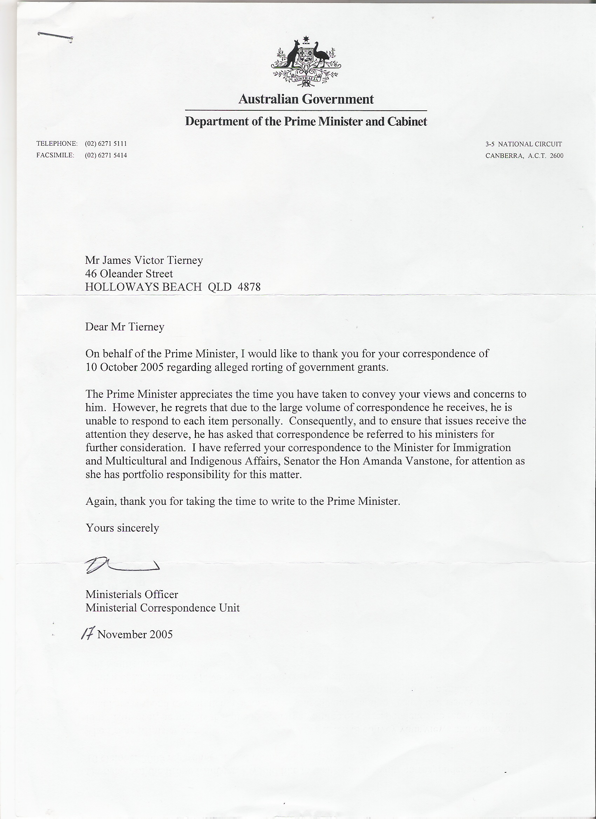

COPY
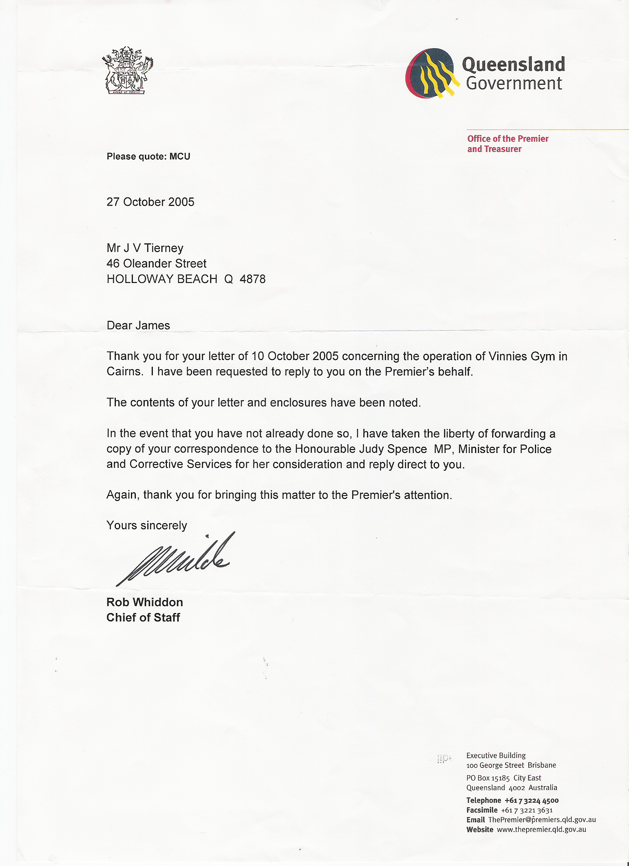

●●●●●●●●●●●●●●●●●●●●●●●●●●●●●●●●●●●●●●●●●●●

●●●●●●●●●●●●●●●●●●●●●●●●●●●●●●●●●●●●●●●●●●●
COPY
Hon Judy Spence MP
Minister for

Police and Corrective
Member for Mount Gravatt

Response to Ministerial Correspondence Received by E-mail

Mr James Tierney
jjls@bigpond.com

Dear Mr Tierney

Thank you for your email of 25 January 2006 concerning the operation of
Vinnies Gym in Cairns and the legitimacy of statutory declarations.

This matter is receiving attention and you will be advised further as soon as possible.

Yours sincerely

Judy Spence MP
Minister for Police and Corrective Services

Level 24 State Law Building

50 Ann Street Brisbane

PO Box 15195 City East
Queensland 4002 Australia

Telephone +61 7 3239 0199
Facsimile +61 7 3221 9985

●●●●●●●●●●●●●●●●●●●●●●●●●●●●●●●●●●●●●●●●●●●

