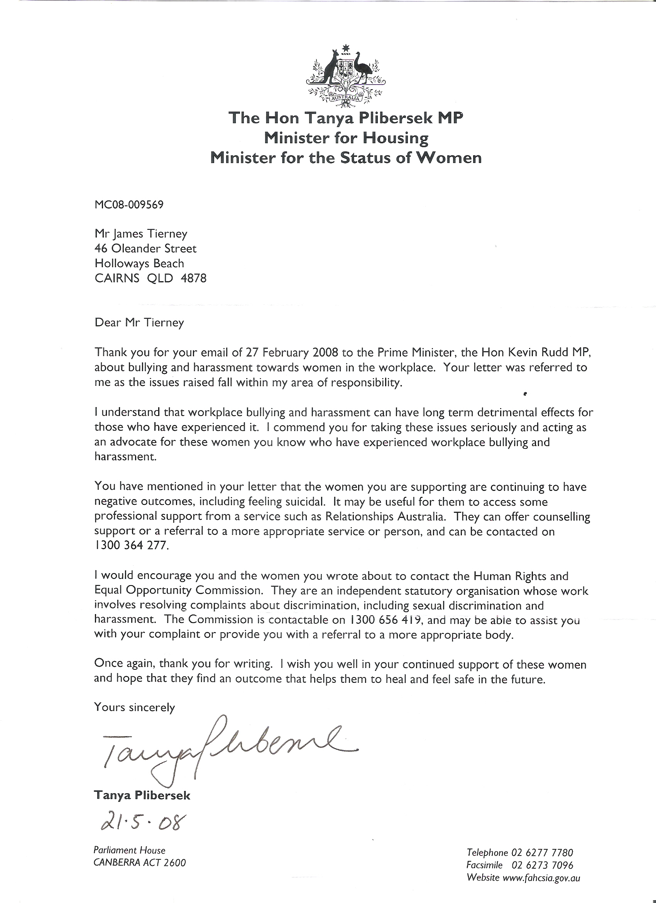
Does this look like a letter to a man that king hit a child as publicly stated by Queensland society ceo Peter Maher.
Or to a man that is being set up by Queensland police and a Cairns indigenous boxing trainer. Alleging I hit a 50 kg kid I had trained since he was in school in the back of his head with both my elbows I weigh 130 kilo of muscle.
I am a highly ranked power lifter extremely high experienced martial artist an Olympic Weightlifting coach and a professional licensed boxing trainer?

Incidentally, this 50-kilo liar went on the same evening and had two boxing fights this was after they alleged being hit with both my elbows to his head from a 130-kilo power lifter?

