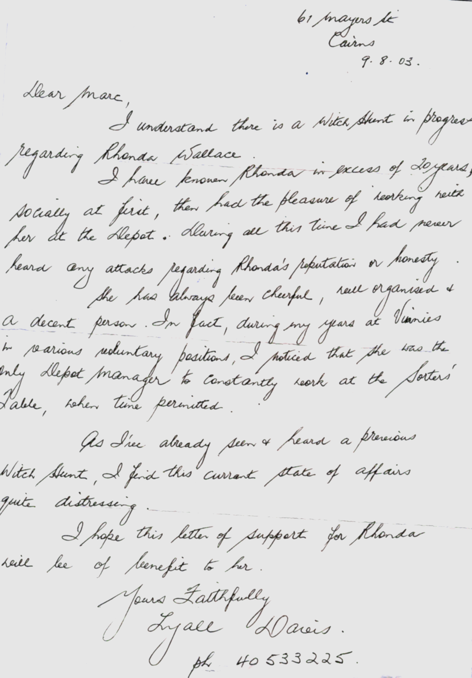
Seeing the minister John Mickel is too important to contact us personally if a KEN MAKAY is around I assume he is another letter writer give him this as he was the last contact to Rhonda Wallace before another letter writer appeared.
This lady thinks the same as we all do about you heartless men that do not get concerned when women are bullied as they are here in Queensland and none of you are bothered shame on you all. Lyall Davies Ph 40533225

TRANSLATION FOR ALL YOU HONOURABLE MEN
61 Mayers St
Cairns
9. 8. 03

Dear Marc,
I understand there is a With Hunt in progress regarding Rhonda Wallace.
I have known Rhonda in excess of 20 years,
Socially at first, then had the pleasure of working with her at the depot.
During all the this time I had never heard any attacks regarding Rhonda’s
reputation or honesty.
She has always been cheerful, well organised &a decent person. In fact, during my years at Vinnies and various voluntary positions, I noticed that she was the only Depot manager to constantly work at the sorters’ table when time permitted.
As I’ve already seen & heard a previous Witch Hunt, I find this currant state of affairs quite distressing.
I hope this letter of support for Rhonda will be of some benefit to her.

Yours Faithfully
Lyall Davies

Ph 40533225

