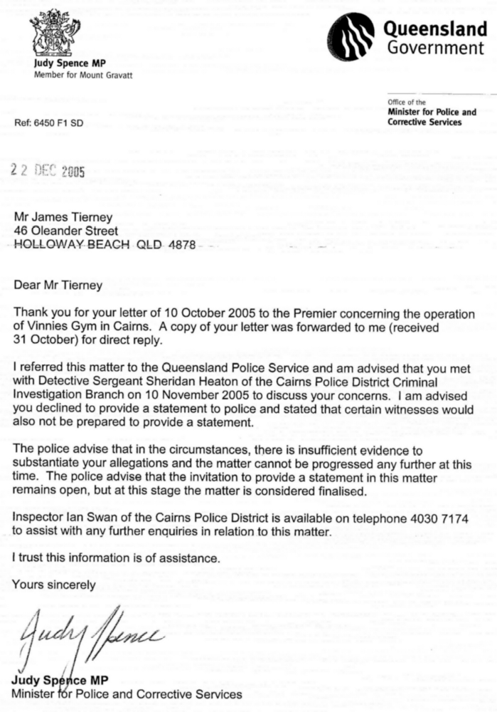
This is how long my wife and me have been persecuted by the Society of St Vincent de Paul.
After receiving this letter from Judy Spence I went with my wife Judith Tierney to get advice and sign any form of statements for Qld police Inspector Ian Swan. We were bullied out of the inspectors office after him telling us he was a Catholic - even though John Howard Prime Minister at the time had received four independent witnessed Statutory Declarations stating we were all harassed and bullied by Society officials to falsify the numbers of only indigenous people that were attending Vinnies Gym this was for the Society to be able to apply for government grants.
One of these instructors is Tony Walsh Queensland Justice of the Peace # 99975.

This harassment started as soon as I erected all my donated equipment ALONE I MIGHT ADD!
Right from the inception of Vinnies Gym the instructors were consistently ordered to falsify the numbers of only indigenous people that were attending Vinnies Gym.
There is no end to our persecution we have been vilified by not only Society ceo Peter Maher but any of this Society’s acquaintances.
These include Warren Pitt, the current Qld minister for disabilities Lee Norris
Senior Policy Advisor
Judy Spence Qld police minister, Qld Premier before Beatie and now after

